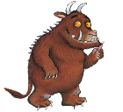Gruffalo STEM Grid P2 Thursday 13th of August

Here are a choice of 10 STEM activities that you can use at home to help children develop their science, technology, engineering and maths skills. Please choose 2 or 3 activities to complete. These activities are easy to resource, however, please adapt to any resources you have at home, please just do what you can, when you can, if any! These activities provide children with the stimulus to talk about the world around them. Don’t forget to please share your work with us, if possible. We would love to see what you are up to!
If you don't have this story at home, please follow this link to see the story. A copy of this will be available on the school Blog to assist with web links.

https://www.bbc.co.uk/iplayer/episode/b00pk64x/the-gruffalo
Imaginary Creature  Write a report about or draw an imaginary creature and tell your family member about it. What does it eat? Where does it live? How is it adapted to live in that place? | Animal Research  Look at the illustrations in the book and find out about all of the different animals shown in the book.  Choose HOW you wish to present this information and share with a family member, friend or your teacher.  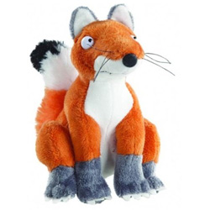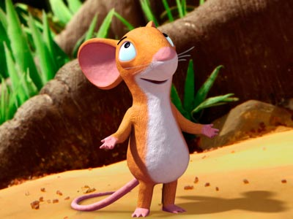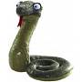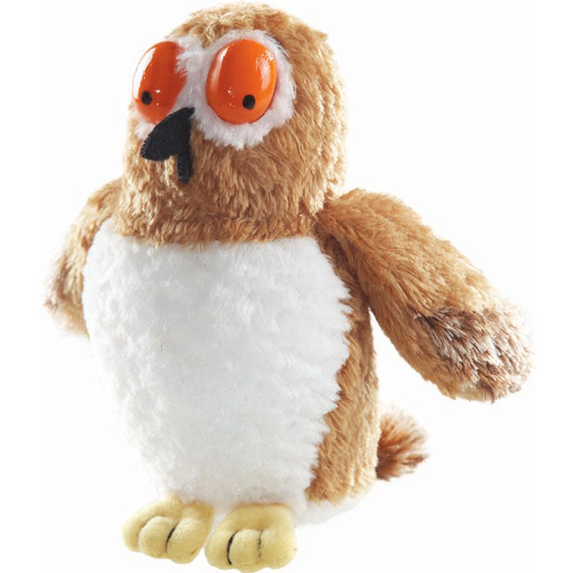 |  | Gruffalo Crumble  Here is a no bake recipe if you wish to use it  https://mummy2twindividuals.com/world-book-day-no-bake-gruffalo-recipe  Activity  Make a fruit crumble together: fresh, frozen, or tinned fruit can be used and oat toppings can be used instead of flour which can be difficult to find just now  Demonstrate: show your child how to weigh and measure, pour and mix.  Talk about what you are doing together: Talking about the ingredients, where they came from, what they feel like, smell like and taste like will support language and communication development. Discuss being safe while baking  Enjoy learning together and eating what you have made together.  Gruffalo crumble can also be made outside from mud, stones, sticks, moss etc.  Have fun and share!
Gruffalo Model  What I need to do: You will need to create the Gruffalo’s head using a cereal box or a shoe box.  Step 1: Collect the materials you would like to use to create your Gruffalo’s head such as a cereal box, coloured paper, glue and paint. You may also use dry rice or pasta to add texture!  Step 2: Cover your box with brown paper or brown paint and cut out the shapes needed for the ears, eyes, nose, teeth and horns.  Step 3 Assemble your Gruffalo’s head by sticking and drawing on the parts of his face.  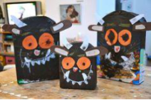  Resources I will need:  Cereal box, shoe, box, collage materials (tissue paper, pom-poms, pasta, rice) colouring pencils, paint, scissors, glue, sticks, buttons, pipe cleaners |  |  | Story Stick  Equipment  Length of stick up to 30cm long and not less than 2cm in diameter  Elastic bands  Outside space  How to make your story stick  Go outside for a walk. While you are walking look out for interesting  natural objects. This could be twigs, leaves, seeds, feathers and lots of  other things. When you see something interesting, pick it up and use an  elastic band to attach it to your stick. When you have completed your story stick, use it to remember some of  the things you saw, heard, felt, or learnt about on your walk.
Den Building  Build a Den for the Gruffalo. You could build it in your bedroom of the corner of a room.  Resources- use what you have!  Dens can be built insode, over chairs, pieces of furniture or clothes OR outside, over bushes with a blanket, pegs etc |  | Nature Hunt  Collect leaves, encouraging a wide range of  types and a variety of textural words. Create a leaf picture with all of the leaves that are your favourite.  Keep ‘special’ leaves in treasure bag. | Shadow Puppet  Design a Gruffalo shadow puppets. Another idea would be to create lots of shadow puppets, creating all the characters and retell the story.  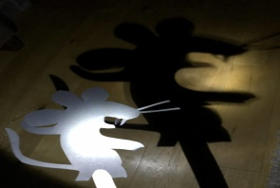
Online Gruffalo Game  https://www.gruffalo.com/in-the-woods/?ReturnUrl=/activities/activities  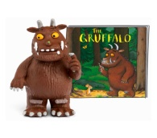 |  | Gruffalo Potion  Make up some ‘potion’ from natural items mixed with water in a pot which could scare a gruffalo away.  Either write out the recipe or record by sticking items to cards with double sided tape.

