HARRYSMUIR PRIMARY SCHOOL
SCHOOL IMPROVEMENT PLAN

2022 / 2023

Factors Influencing the Improvement Plan

School Factors
Addressing Action Points identified in school’s Self Evaluation procedures
Cluster Improvement Priorities
Equity Priorities

Local Authority Factors
Moving Forward in Your Learning Guidance
Literacy and Numeracy West Lothian Priorities, HWB
Raising attainment, including closing the gap (West Lothian Raising Attainment Strategy)
Transforming Your Council
Corporate Plan
Education Services Management Plan
West Lothian Parental Involvement and Engagement Framework
Equity Team and additional allocations, Pedagogy Team
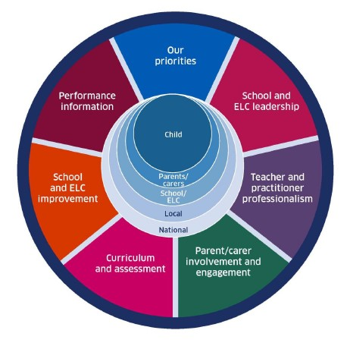
National Factors
Coronavirus (COVID-19): Guidance on reducing the risks from COVID-19 in school
Moderation Cycle and Assessment
National Improvement Framework / Scottish Attainment Challenge / National Improvement Hub / Raising Attainment for All
Pupil Equity Funding/Equity Audit
How Good is Our School? 4th Edition and How Good is Our Early Learning and Childcare?, National Standard for ELC, Quality Framework for day care of children
Getting it Right for Every child (GIRFEC)
Curriculum for Excellence Refresh
Realising the Ambition
Developing Scotland’s Young Workforce
Child Protection Procedures
GTCS professional standards and professional update 2021
Achieving Excellence and Equity 2022: National Improvement Framework and Improvement Plan
Putting Learners at the Centre: Towards a Future Vision for Scottish Education, The Ken Muir report, March 2022.
UNCRC
Presumption to provide education in a mainstream setting 2019
Support for Learning: All our Children and All their Potential (ASL Review) 2020
Vision, Values and Aims:

Our vision for Harrysmuir is “where the magic happens!” and through this, we endeavour to provide motivating, aspirational educational of the highest quality for all children, within an ethos of mutual respect. We seek to uphold the rights of all children and to meet their educational, personal and spiritual needs, which will enable them to be successful learners, confident individuals, responsible citizens, and to make an effective contribution to society in their present and future lives. We have a strong commitment to ensuring excellence and equity for all our pupils and believe that everyone has the capacity to realise their full potential and to succeed. Our 5 core values sit firmly at the centre of what we want for all of our children: the desire for them to show Determination in their learning, Kindness and Respect for others whilst taking Responsibility for their own actions, to enable them to make positive choices, which will lead to their own success and Happiness.

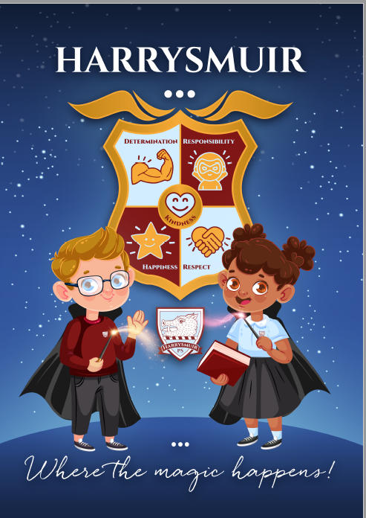

Harrysmuir’s Curriculum for Excellence in the Recovery Phase - Curriculum Rationale can be accessed on the school website -

https://harrysmuirprimary.westlothian.org.uk/article/15284/School-Documents
Contextual Data Analysis and Rationale for 2022/23 School Improvement Plan (maximum one side A4)
- Background - The context for the learners in your school:

Harrysmuir Primary School is part of Harrysmuir Learning Community, which also includes, Inveralmond Early Years Centre (IEYC) and Ladywell Nursery School (LNS). Harrysmuir Primary School has a current roll of 388 and a FME entitlement of around 40%. 88% of our children in the school live within quintiles 1 & 2 whilst only 8% live in quintiles 4 & 5. Across the school as a whole, there is generally an equal gender balance however this varies from class to class. We currently have 15 classes, with one composite class, a small group provision for children with ALN, and two nurture resources.

Our school benefits from a large senior leadership team, led by our Headteacher. We also have a wide staff team, encompassing teaching staff, pupil support workers, ELC practitioners, admin, clerical and facilities management staff. Each member of our staff team is committed to providing the very best education and care for children in our school. We are supported by a Parent Council and wider parent body, as well as a number of partner organisations, from within the local area.

- Data to identify the universal and targeted school Improvement Plan Priorities (SIP)

Our school roll is currently sitting at 388 pupils, distributed across 15 classes in school. Around 51% of our total pupil roll are boys and 49% are girls. Our gender balance across school is therefore, almost equal. We have 12 care experienced/LAAC children within our school. Most of our children reside with a Decile 1-4 postcode and there is a free school meal uptake of around 40%. Around 88% of our children are in Quintile 1 or Quintile 2. The school is ranked as 11 out of 68 primary schools in the authority, where number 1 is the most deprived school and number 68, the least. The school therefore benefits from a substantial, pupil equity fund allocation each year.

Additional support needs: Across our school roll, we support a number of children with additional support needs including, Autism Spectrum Disorder (about 3% of our total pupil roll), English as an Additional Language (about 16% of our total pupil roll) and Dyslexia (about 2% of our total pupil roll).

Early Years Trackers: Data from our early years trackers 2021/22 (Ladywell Nursery School and Inveralmond Early Years Centre) shows a need to focus on improving pupil progress and attainment in aspects of Numeracy and Math, before they move into P1.

Wellbeing – In our most recent pupil wellbeing questionnaires, Most of our pupils (85%) rated that they feel Healthy, Safe, Included and Respected in our school, and show that they are aware of how to stay Active and Healthy. Our Q1 and Q2 children (85%) also rated positively across all of the Wellbeing Indicators, however there was an 8% gap between the percentage rating of these children and those in Quintile 5 (94%), meaning that there is a small percentage difference in how pupils report on their wellbeing, between our most and least advantaged postcodes. This is something that the Senior Leadership Team will seek to address in planned interventions for session 2022-23.

Pupil Engagement – Teachers report, through their professional judgement, that most pupils are engaged in class during learning experiences in Literacy, Numeracy and Health and Wellbeing. This is evidenced in our pupil tracking data. Our Quality Improvement evidence from recent learning walks, would suggest that whilst all most all pupils are compliant with the expectations of the lesson, more work needs to be done to ensure the full engagement of all children.

CFE Tracking data: Our Curriculum for Excellence data for session 2021-22, based on Teacher Professional Judgement, shows the following:

- There is a 20% increase in our P1 attainment in Literacy from last session (2020-21).
- Most children now reach the required levels in Reading, Writing, Listening and Talking and Numeracy and Maths by the end of P1.
- Children’s progress at the end of Early level into First Level is not yet sustained. Our P2 and P3 shows that there is work to be done to ensure the correct progress for all children, as they move through First Level, in Literacy and Numeracy/Maths.
- At P4, our pupil attainment levels dip. A focus next session, needs to be on improving children’s progress in all areas, but especially in Writing.
- Our P6 and P7 data this session, has been very positive and generally progress in the upper stages of our school appears to be on par with the authority average. We aim to sustain this next session.
- Boys across our school, tend to do less well in all areas of Literacy (Reading, Writing and Listening and Talking) and at all stages, than girls. This is an improvement opportunity for next session.
- Our Q1 children perform better in all areas of the school than our Q2 learners. More work needs to be done to understand the needs of the children in the Q2 group and to ensure that interventions have a positive impact on their barriers to learning.
- There is a 20-30% gap between our Q1 and Q5 children in Literacy at all stages, which must be continued to be addressed in our forthcoming PEF plan and using our Scottish Attainment funding.
- Our pupil attainment for the Maths element of Numeracy and Maths could potentially be higher in all classes across school. Children often perform better in this area than in Numeracy but this is not the case in our school. Programmes of study need to be re-explored to look at teaching in this area.

 | Roll | Literacy | Reading | Writing | L&T | Numeracy
P1 21/22 | 43 | 67.44% | 72.09% | 72.09% | 83.72% | 72.09%

 | Roll | Literacy | Reading | Writing | L&T | Numeracy
P4 21/22 | 61 | 59.02% | 68.85% | 65.57% | 77.05% | 65.57%
 | Roll | Literacy | Reading | Writing | L&T | Numeracy
P7 21/22 | 53 | 77.36% | 86.79% | 81.13% | 94.34% | 79.25%

Digital Connectivity: We have increased our digital technology resources across school this session. Across a stage, each class has access to a laptop trolley and iPads for at least half of the week. We have supplied a number of families with appropriate hardware and Internet connectivity to enable all children to have full access to our home-learning programme.

Participation: Pupil participation across the 4 contexts of learning continues to be a focus for whole-school improvement. The re-introduction of extra-curriculum groups and clubs this term, has enabled a greater number of pupils (including those in Q1 and Q2) to participate in sports, art and other clubs. We actively encourage all children to attend clubs and we have adapted our school football team, this session, (including the selection process), to allow for greater inclusion.

Our improvement priorities based on evidence:

- All (100%) pupils will benefit from a progressive, cohesive health and wellbeing curriculum from Primary 1 to Primary 7.
- Most (80%) children will make the required progress in Writing and Numeracy and Maths, across the school, and especially at First Level.
- The majority (70%) of male pupils, and especially those in Q1 and Q2, will make the required progress in Reading and Writing by the end of Second Level.
- The majority (50-60%) of learning experiences, across school, will be linked to our school values and The Career Standard, to increase pupils’ skills for learning, life and work.

Harrysmuir Primary School - School Improvement Planning for Ensuring Excellence and Equity
School priorities linked to knowledge and data as identified on previous page | NIF Driver | Proposed actions | Timescale | Measures of Success
Improvement in all children and young people’s wellbeing:  All (100%) pupils will benefit from a progressive, cohesive health and wellbeing curriculum from Primary 1 to Primary 7.  (Placing the human rights and needs of every child and young person at the centre of education) | ☐School and ELC Improvement.  ☒School and ELC Leadership  ☒Teacher and Practitioner Professionalism  ☒Parental Engagement  ☒Curriculum and Assessment  ☒Performance Information | Universal interventions:  - Audit of H&WB organisers and current programmes of study/resources in place to ensure full curriculum coverage for all children, at all stages.  - Refresh programmes of study, teaching progressions and resources to ensure that are progressive and relevant, at all stages, to meet pupil needs. Ensure programmes of study/teaching progressions are linked to Children’s Rights and school values.  - Pupil wellbeing committee to be set up to lead improvements in H&WB across school.  - Ensure that there are consistent approaches to the way that children self-report on wellbeing across school- use of incredible 5 point scale?  - Ensure that staff are aware of latest H&WB guidance and news, plus have access to relevant CLPL- through school H&WB Champ.  - Ensure that all families have access to relevant info re progress in our H&WB curriculum through newsletters, Twitter and our H&WB Family Champs.  - Staff wellbeing committee to be set up to include social events and support for H&WB e.g. staff book club, running/walking group etc.  Targeted interventions:  - Create a range of groups/supports for children with barriers to learning, related to wellbeing and including those in Q1 and Q2 e.g. bereavement group, upper and infant nurture, Rainbow Room, Breakfast and Lunch Club, gardening group, Green Gym etc.  - Ensure that interventions above are carefully measured for impact. | By April 23 | - Termly, pupil H&WB questionnaires to show 5% increase in children reporting positively across all wellbeing indicators. Overall 90% positive response rate.  - Pupil voice group evidence- discussions around wellbeing indicators to indicate pupil knowledge of what it means to be safe, nurtured, healthy, included etc.  - Daily self-reporting evidence from class teachers to show that 90% pupils are happy and settled in class.  - Learning walks to evidence presence of self-reporting in all classrooms.  - Staff/Parental knowledge questionnaires- H&WB- to show that the community understands the meaning of ‘wellbeing’ and where/how to access support.  - Variety of staff wellbeing events- attendance figures for each.  - Boxhall profiles to show improvements to social/emotional wellbeing- before and after for children who undertake targeted interventions i.e. nurture.  - Before and after wellbeing questionnaires for children who undertake interventions.  - Pupil engagement measures e.g. Leuven scale for targeted interventions to evidence children on task and participating.
Raising attainment for all, particularly in literacy and numeracy(universal):  Most (80%) children will make the required progress in Writing and Numeracy and Maths, across the school, and especially at First Level.  (Placing the human rights and needs of every child and young person at the centre of education) | ☒School and ELC Improvement  ☒School and ELC Leadership  ☒Teacher and Practitioner Professionalism  ☒Parental Engagement  ☒Curriculum and Assessment  ☒Performance Information | - Review of writing pedagogy to be conducted across school. Audit of current practice and agreed, consistent approaches and standards for the teaching of writing across school to be put in place. Use the support of the Literacy Pedagogy Officer.  - Pupil voice groups to set up to consider children’s views on writing.  - Continue to establish a calendar of writing activities, with links to teacher planning, to ensure children write across the 4 contexts of learning.  - Teachers to work collaboratively to establish clear procedures for the effective use of target setting and feedback in writing.  - Teachers to work collaboratively to ensure that all aspects of the moderation cycle are embedded in the teaching and assessment of Writing across school.  - Writing support/booster groups to be set up for children in key stages at First Level- P3 and P4.  - With the support of the Numeracy Pedagogy Officer, re-explore the teaching of Maths concepts e.g. shape, measure, data handling across school and put in appropriate programmes of study for each stage. | By June 22 | - Learning walks, classroom observations and pupil voice groups to show that writing guidance is being applied in 95% of class across school.  - At least 70% of pupils across P1-7 to report positively on writing, in pupil perception questionnaires.  - All (100%) teacher’s planning documents (daily and long term) to show writing across the 4 contexts and genre with a clear assessment focus each term.  - 85% of children who attend writing support groups to go up a tracking level, (moving from 2 to a 1, or 3 to a 2), by June 23.  - All (100%) of teacher planning (long and short term) to show progressive teaching in maths concepts (e.g. shape, measure, data handling) across school.  - Attainment in Maths to increase by at least 15%, at all stages, by June 23.
Tackling the attainment gap between the most and least advantaged children (targeted):  The majority (70%) of male pupils, and especially those in Q1 and Q2, will make the required progress in Reading and Writing by the end of Second Level.  (Placing the human rights and needs of every child and young person at the centre of education) | ☒School and ELC Improvement  ☒School and ELC Leadership  ☒Teacher and Practitioner Professionalism  ☒Parental Engagement  ☒Curriculum and Assessment  ☒Performance Information | All schools have a separate Pupil Equity Funding Plan to ensure that children and young people affected by poverty achieve their full potential, focusing on targeted improvement activity in literacy, numeracy and health and wellbeing.  *See PEF plan for the SMART targets and interventions to meet this priority but in summary:*  - Work with the Literacy Pedagogy Officer to re-examine reading programme and resources used to interest boys.  - SFL and PSW staff to provide ‘reading recovery/reading acceleration’  - Boys to have access to ‘new’ school library and variety of texts on offer- pupil led reading club to be set up?  - PT to set up an outdoor learning group to encourage ‘reading and writing in the outdoors with an identified group of male pupils. | By June 23 | Documented in PEF Plan  *See specific interventions and measures in PEF/Equity plan.*
Improvement in employability skills and sustained, positive school leaver destinations for all young people:  The majority (50-60%) of learning experiences across school will be linked to our school values and The Career Standard, to increase pupils’ skills for learning, life and work.  (Placing the human rights and needs of every child and young person at the centre of education) | ☒School and ELC Improvement  ☒School and ELC Leadership  ☒Teacher and Practitioner Professionalism  ☒Parental Engagement  ☒Curriculum and Assessment  ☒Performance Information | - Staff working group set up to further develop learning progressions in social subjects/IDL and approaches to teaching, planning and assessing IDL considering digital learning as a driver.  - Pupil leadership groups across school to be broadened to include STEM/ UNCRC and 1+2.  - Extra curriculum programme to include opportunities for pupils to develop skills for learning, life and work. | By April 23 | - Staff working group for Social Subjects/IDL curriculum, in place, alongside distributed leadership roles. Working group action plans to detail long and short term aims and impact on learners of improvements to Social Subjects/IDL teaching.  - Pupil leadership group action plans and ‘working wall’ to highlight impact of learners and wider school from STEM, 1+2, UNCRC/RRS etc.  - Pupil focus group evidence to display evidence of pupils linking subjects to skills for learning, life and work and benefits of learning.

