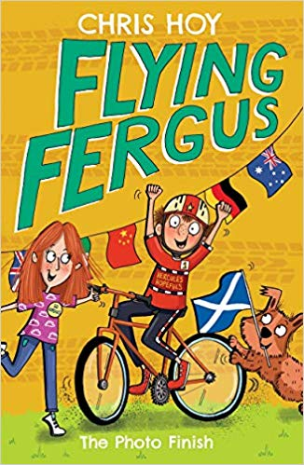
3 Author
- Who is the author?
- Do you recognise the name?
- Have you read any other books by this author?
- Is the author famous for anything else?
4 Setting
- Where is the story taking place?
- What clues have the author and illustrator given us about the setting?
- What flags can you see? Why might there be flags?
5 Genre & Plot
- What genre is the story? How can we tell?
- What do you think the story will be about? Why do you think this?
- Who do you think the book is aimed at and why?
- Do you have any experiences that might be similar to the characters in the story?
1 Characters
- Who are the main characters?
- Can we work out anyone’s name? Why has the author chosen this name?
- Describe what the character look like.
- What emotions are they feeling? How do you know this?
- What are the characters doing? Why do you think this?
2 Title
- What does the title of the book tell us?
- Where might we hear the term ‘photo finish’ and why might it be used?
What to do:
- Choose at least 2 questions from each box (characters, title, author, setting and genre & plot) to answer. This means you should answer a minimum of 10 questions.
- Refer back to the question to ensure you have answered it to the best of your ability.
- Type your answers into the coloured text boxes on the next page or into a new word document.
- Make sure we know which questions you are answering e.g. if you are answering a question about characters use the number ‘1’ followed by the letter – 1a.
- Answer in full sentences, using capital letters where appropriate and correct punctuation.
- Remember to support your answer with evidence e.g. I think _____ because _____.

1 Characters
3 Author
2 Title
5 Genre & Plot

4 Setting
5 Genre & Plot

