Hello Primary 5.
Below are the times in which you will have meetings with Miss Gorman or Miss Armstrong on Teams. These will all be hosted through the ‘General’ channel. All you will need to do is click ‘Join Meeting’.
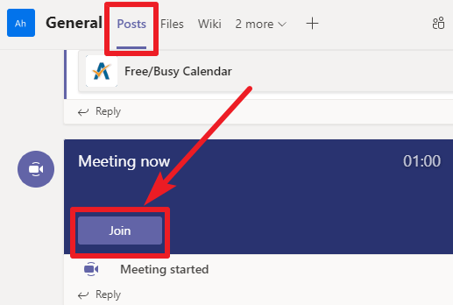
Check in will be where classes can catch up and share news with one another.
Snack and story will be your teacher reading different stories or novels for around 10mins. Come and listen with a snack and drink.
Question Time is where you can come on and ask questions about your learning that day or anything you need more help with.
Please take a look at the next page to see when your class will have their meetings next week.
On days that your teacher is in school and not on Teams the other Primary 5 teacher will be available to assist you – just post on the General Channel and they will get back to you when they can.
We hope this will help you with your learning and give you a routine for your home learning.
Miss Gorman and Miss Armstrong
Class timetable
 | Miss Gorman (P5A) | Miss Armstrong (P5B)
Monday 11/1/21 | Check In – 9am  Snack and Story – 10am  Question Time – 1:30pm - 2pm | Snack and Story – 9:30am  Check In – 10:30am  Question Time – 2pm – 2:30pm
Tuesday  12/1/21 | Snack and Story – 10am  Question Time – 1:30pm - 2pm | Snack and Story – 9:30am  Question Time – 2pm – 2:30pm
Wednesday  13/1/21 | Snack and Story – 10am  Question Time – 1:30pm - 2pm | In School
Thursday  14/1/21 | In School | Snack and Story – 9:30am  Question Time – 2pm – 2:30pm
Friday  15/1/21 | Check In – 9am  Assembly – 10am  Question Time – 11:45am – 12:15pm | In School

