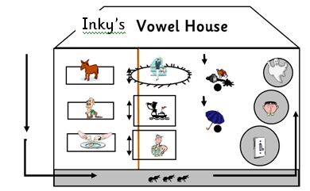

**Inky’s story**

From the top window look over at the donkey saying ‘**ee’** . He has a bad throat and this is all he can say.

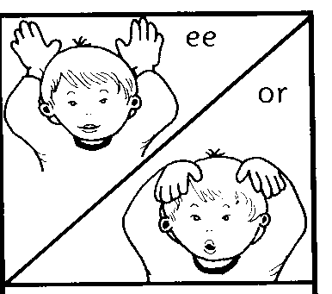



j0141317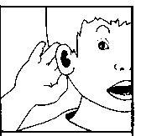**Down on**  the second floor is an old man who can’t hear very well saying ‘**ai’.**

**What did he say?**

Down on the ground floor, mum is in the kitchen cracking eggs ‘**e’** .

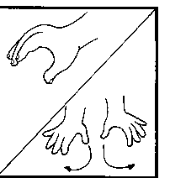

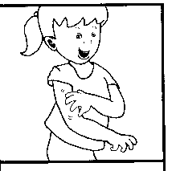Down in the basement ants are scurrying to the back of the house ‘**a’**.



MCj03403080000[1]

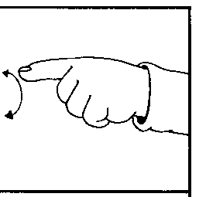

It’s very dark. Quick! Let’s turn on the light ‘**o’**.

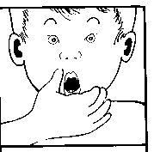Oh no! It is broken and it’s not working! ‘**oa**’

‘Oh no!’ groans Joe Comb.

MCj03799870000[1]Listen! Who can you hear in the darkness? …..a spook going ‘oo’

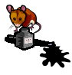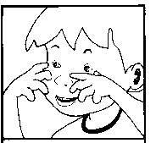

This scares poor Inky mouse.

He jumps down from the loft and spills the ink **‘i’**

umbrella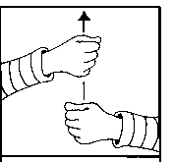

Quick! Get the umbrella up ‘u’

***But the vowels that live on the lift are different. They keep moving!***

***The sailor’s story***

The sailor shouts “Aye, aye captain, ‘igh’ (salute towards the eye)

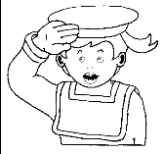I’ll climb up to look out for land

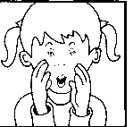The sailor looks for land and when he sees land he shouts, ahoy ‘oi’

MCj02871670000[1]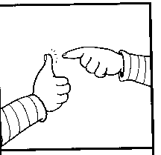But the sailor is so excited that he falls out of the crow’s nest! ‘ou’