Primary 3 Activities Week Beginning 9th November 2020

Choose from the activities below to complete over this week. You do not have to do them all.
Remember to spend quality time with the people you live with too!
Maths  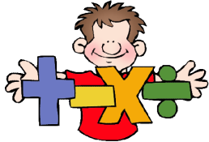 | Literacy  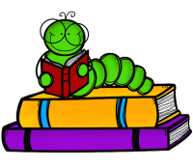 | Health & Wellbeing   | Additional Tasks  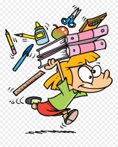
Maths:  Log onto Sumdog and complete the Measure assessment.  Choose and complete either Odd or Even Numbers to 20 or Odd and Even Numbers to 100 Worksheet.  Challenge:  Find numbers around about your house and decide whether or not they are odd or even. | Spelling:  Choose one of the spelling worksheets to complete.  Handwriting:  Choose one of the Handwriting sheets to complete.  Reading:  Read your favourite book to someone in your house.  Writing:  Write about what you have been doing whilst being at home this week or write instructions to something you have made at home. Remember to include a Title, Goal, Materials and Steps. | Health and Wellbeing  Keep yourself active at home by taking part in a Joe Wicks Fitness Challenge. Click on the link below.  https://www.youtube.com/watch_popup?v=d3LPrhI0v-w  Mindfulness:  Complete the Things that make me happy worksheet or make your own Breathing Wand.  https://www.youtube.com/watch_popup?v=4esq5na5js0 | Modern Languages  Read the PowerPoint on French Body Parts and complete the French Body Parts Worksheet. (You can either write out your answers or cut and stick your answers onto the worksheet.)  Learn how to sing heads, shoulders, knees and toes in French.  https://www.youtube.com/watch_popup?v=0EFXCdryyRM&app=desktop
All worksheets/ PowerPoints are attached onto the blog and on Seesaw.

