Primary 3 – Week 12 22/6/20 – 26/6/20
Writing | Reading | Number
Summer Holiday  Make a choice: Are you going to write about your last or your next summer holiday?  What did you do? OR What are you going to do?  Where did you go? OR Where will you go?  Who did you go with? OR Who are you going with?  How long did it last? OR How long are you planning to stay?  How did you get there? OR How are you getting there?  What did you see and do there? OR What are you going to see and do there?  Did you enjoy it? (explain why) OR Do you think you will have a good time? (Why?) | What is your favourite book?  Read it | 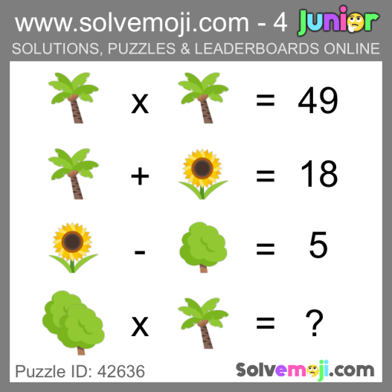  What is the value of the palm tree, the sunflower and the tree?  Can you work out the final equation?
Spelling | Talking & Listening | Maths/Numeracy
Log in to Reading Wise and spend 15-20 minutes working through activities.  www.readingwise.com  Revise some sounds from previous weeks or challenge yourself with new words with the same sound in them.  You can also go to www.spellingcity.com/ and type in the spelling words for this week. Play the spelling games using these words or come up with your own words for these revision sounds. | Watch newsround each day and take notes of the main points and discuss.  https://www.bbc.co.uk/newsround | Sumdog  Continue to practice on Sumdog.
Something fun!
Decide on a fun thing to do for 30 minutes with a family member. Ask them to join in. eg play a game.
***** -

