**My Time in Primary**

Name: ___________________________

Age: ____________________________

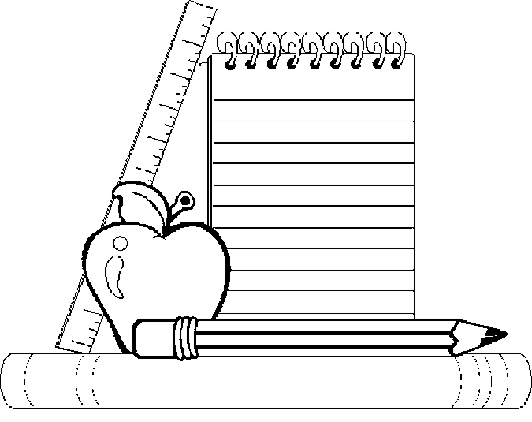

Birthday: ________________________



**My Self-Portrait**

**A few of my Favourite Things**

My favourite subject:

My favourite place in school:

____________________

____________________

____________________

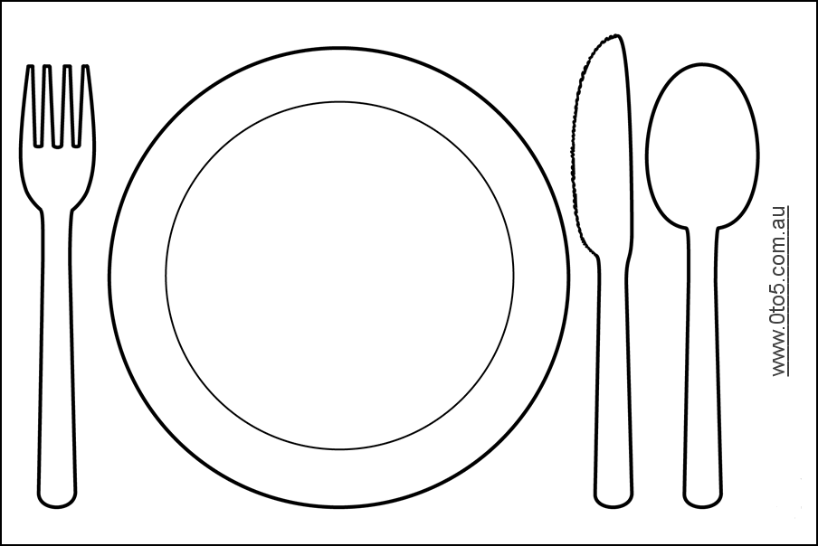



My favourite school lunch:

________________________

________________________

My favourite book:

_____________________

_____________________

_____________________

**My Favourite Things about Primary**



**My Best Memory**

_______________________________________

_______________________________________

_______________________________________

_______________________________________

____________________________________

_______________________

**My Favourite Lessons**

Subject: _______________________

______________________________________

______________________________________

Subject: _______________________

______________________________________

______________________________________

Subject: _______________________

______________________________________

______________________________________



**My Best Friends**

My best friends are: _________________________

_________________________________________

_________________________________________

Because: __________________________________

_________________________________________

_________________________________________

_________________________________________

_________________________________________

**My Achievements**









Reading ………………………………………………………………..

Writing ………………………………………………………………..

Spelling …………………………………………………………………

Maths …………………………………………………………………..

Science ………………………………………………………………..

RME ………………………………………………………………………

Topic…………………………………………………………………....

French ………………………………………………………………..

Expressive

Arts ……………………………………………………………………………………..…

Building

Learning Power …………………………………………………………

…………………………………………………………………..

**How I Feel About School**



____________________________________

____________________________________

____________________________________

____________________________________

**What I am looking forward**

**to next year**