Primary 3 – Week 10 08/6/20 – 12/6/20
Writing | Reading | Number
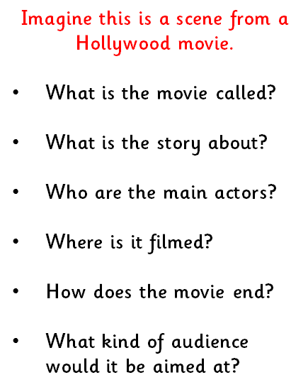  Invent a Plot | P3B  Dragonflies/Butterflies – Key Comprehension Book 1 – Unit 6 Page 22 & 23  Bees/Ladybirds/Caterpillars – ORT Booklet – Page 21 & 22  P3R  Apples – Key Comprehension Book 1 – Unit 6 Page 22 & 23  Bananas/Oranges/Pears - ORT Booklet – Page 21 & 22. | 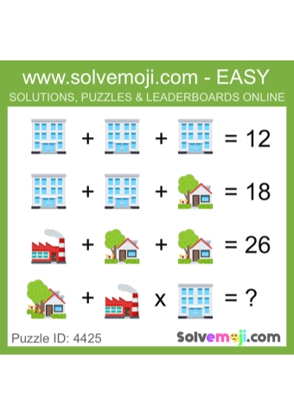  What is the value of the blue window building, the white house and red house?  Can you solve the last equation?
Spelling | Talking & Listening | Maths/Numeracy
Log in to Reading Wise and spend 15-20 minutes working through activities.  www.readingwise.com  On another post called ‘Spelling Challenge’ there will be attached a full list of your groups words and a Spelling Challenge card. Have a go at 2 or 3 of the spelling challenges of your choice.  We are revising our sounds this week. Eagles, Penguins and Robins are revising the sounds ‘kn and mb’. Chicks are revising ‘og’ and ‘ock’.  You can also go to www.spellingcity.com/ and type in the spelling words for this week. Play the spelling games using these words or come up with your own words for these revision sounds. | Watch newsround each day and take notes of the main points and discuss.  https://www.bbc.co.uk/newsround | 2D and 3D Week  Please complete the shapes colouring sheets 1 and 2.  For a challenge have a go of the cube and prism net worksheets.  There is also an assessment sheet to complete to show myself and Mrs Russell your understanding as this will be the last grid we put up.  Please continue to practice on Sumdog as there is a competition that starts on Friday for all classes.
Something fun! | Problem to solve! | Handwriting
Decide on a fun thing to do for 30 minutes with a family member. Ask them to join in. eg play a game. | Kerry has 52 marbles. She gives 6 to Michelle and 5 to Hannah. How many  marbles does Kerry have left?  She now gives half to Luke. How many does she have left? | Please complete pages 20 & 21 in your Nelson Handwriting Workbook Starter C.
***** -

