Week starting – Mon 15th of June = Priority Tasks

Reading  Please use the EPIC Books log-in attached to access the book ‘The 39 Clues – The Maze of Bones’. Please listen or read along to Chapters 14,15 and 16 (The pdf of this book has also been included).  -Please complete the tasks provided for the chapters and use our new ‘BookClub’ channel on ‘Teams’ to discuss what you have read so far. | Writing  Keep a fitness diary whilst completing your virtual health/sports week activities. If you are unable to print this page don’t worry! Keep some short notes about your activities or create a diary of your own.   | Numeracy  Choose one of our mild, spicy or hot puzzles to complete.  Mild- Complete a colour Sudoku (answers included).  Spicy- Make 37  Hot- Escape the Room  Remembers to complete any sumdog challenges set. | Health and Wellbeing  Take part in a Virtual Health/Sports Week:  https://www.thinglink.com/scene/1322897117651402754?buttonSource=viewLimits  
Additional Activities  Sports Day Mindful Colouring sheets.  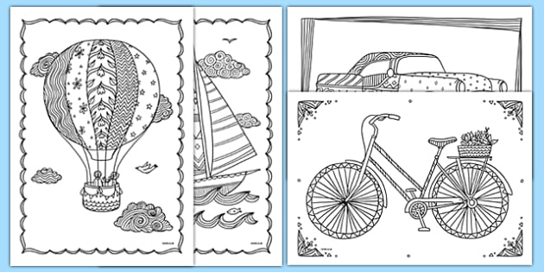 | Additional Activities  Complete Unit 6 Handwriting.   | Additional Activities  Try out one of these healthy recipes! Remember to ask for permission beforehand and some help!  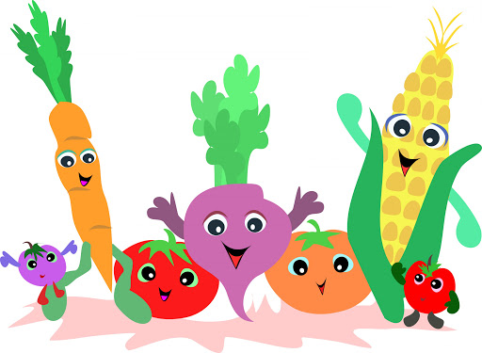 | Additional Activities  Complete ‘The Daily Rigour’. This will be posted on Teams and is made up of maths problems linked to last week’s news.  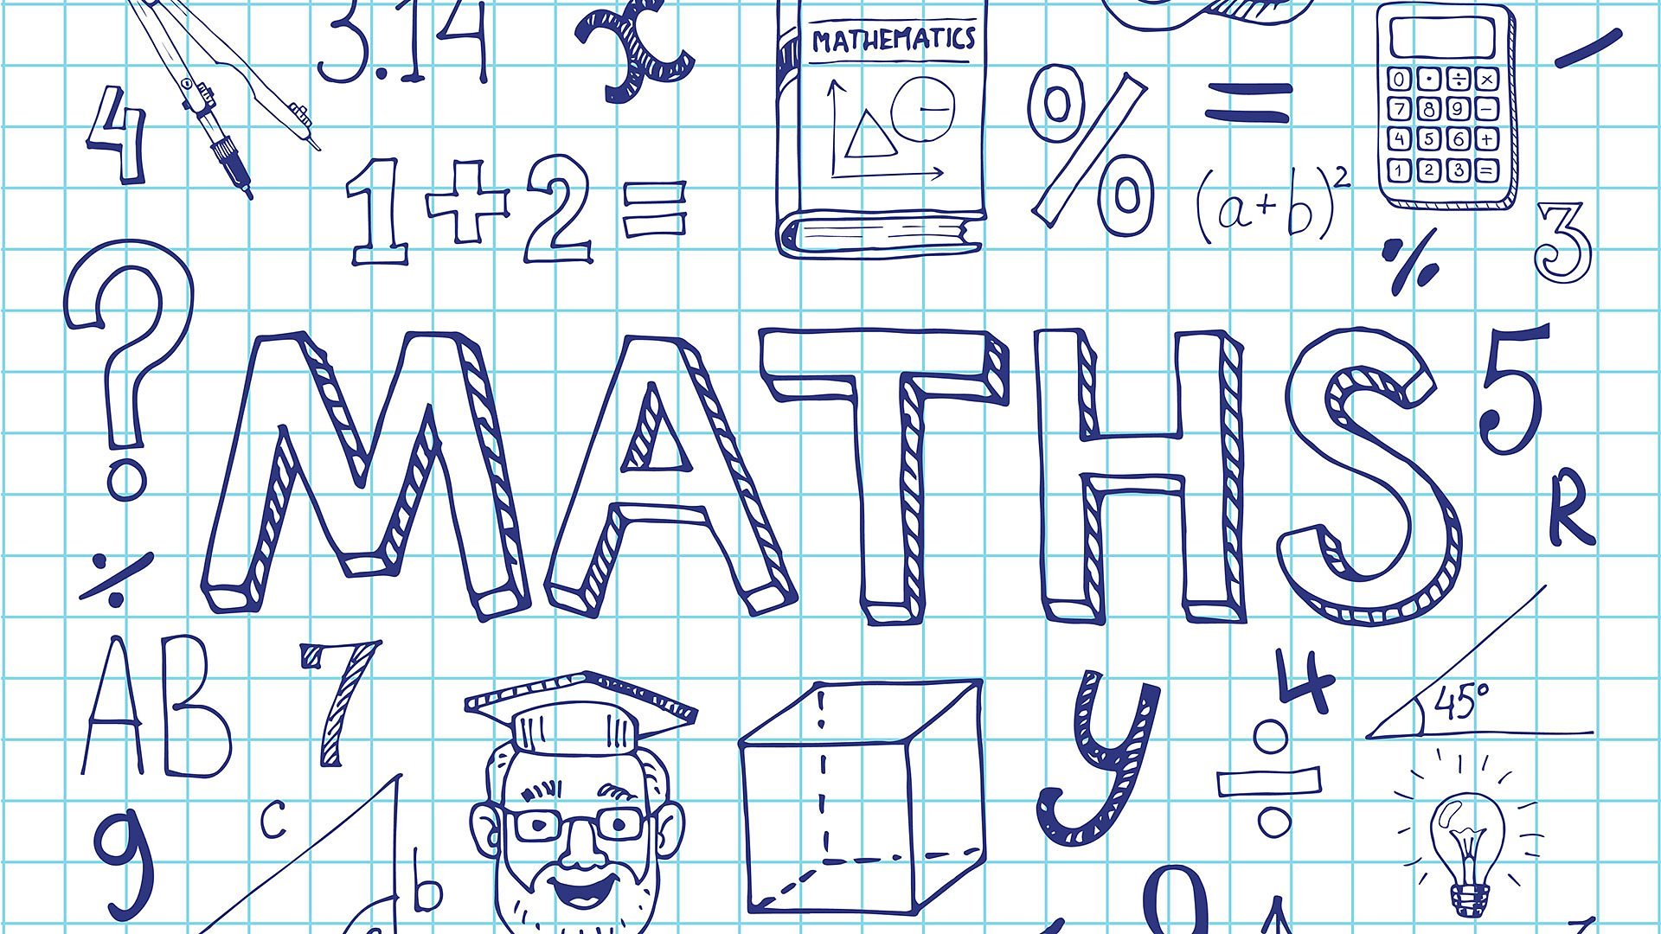

Expectations

- The Learning Grid gives you a range of activities that can be completed each week. The tasks marked with a are priority tasks and we would ask you to complete them each week. These priority tasks will also be set as assignments in your class team on Glow in order that you can share your learning with your teacher and receive some feedback where appropriate.

