**Postcard Activity**

Why don’t you write a postcard to either Mrs Davies or Miss Gorman telling us what your favourite things have been over the last 12 weeks? Whether it’s a piece of work you enjoyed working on, the extra activities we set, a special occasion you have celebrated or just how you have felt during lockdown.

The template is there to help you, you can write the school address and tell us what you have been up to, it is up to you. You could even draw a picture on the other side of the paper.

Can’t wait to read them!!

Dear Mrs Davies/Miss Gorman

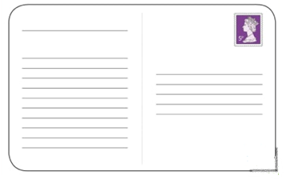

Mrs Davies/Miss Gorman

Harrysmuir Primary School Willowbank, Livingston

EH54 6HW