Human Sundial Experiment
What you will need:
- Chalk
- An open paved space which gets sun most of the day (drive way, pavement, decking)
- Camera
- Tape measure (optional)
- Paper and pencil/pen to record findings (optional)
Method:

STEP 1 – Choose a sunny day when no clouds, rain, or snow is expected.
It is not possible to trace shadows all day unless it is sunny all day. If clouds move in during the day you will have to scrap your human sundial shadow science experiments for another day.

Step 2 – Find an open cement area near your home where the sun shines all day to make a human sundial.
Find a wide-open spot that will be sunny all day. Driveways and pavements work well, but be sure to be safe and socially distanced from others.
Make sure you have enough space in all directions around you, shadows can grow long!
If there are trees or structures near the area you are considering, check the area in the morning, at mid-day, and in the evening to make sure that the area is not shadowed at any time of the day. You need the sun on it to be able to trace your child’s shadow!

Step 3 – Place an ‘x’ on the spot that you will stand each time. You will need to stand on the same spot each time.

Step 4 – Have a parent or sibling trace your shadow using the chalk.
Morning, mid-day, and late afternoon and/or early evening are great times of day to trace shadows for these outdoor science experiments.
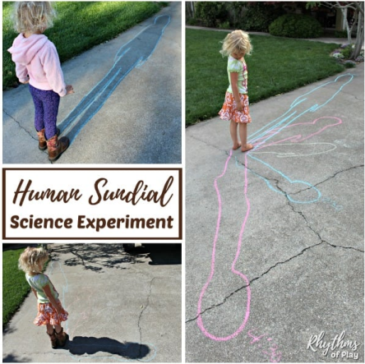
Think of mealtimes as your cue to trace shadows, or set an alarm to go off. Try tracing every 2 hours e.g. at 8:30 am, 10:30 am, 12:30 pm, 2:30 pm, and 4:30 pm. Make sure to mark the time the shadow was traced next to the tracing.
Step 5 – What do you notice about the shadows?
You can discuss this or make notes using the
paper and pen/pencil.

