Primary 3 – Week 10 08/6/20 – 12/6/20
Writing | Reading | Number
  Description using the senses  Challenge: Use a thesaurus to look up the word scary. Choose the best three ‘scary’ words and write a sentence for each one.  Task 1  Describe getting on a roller-coaster and travelling slowly up to the top.  How would you feel?  What might your stomach be doing?  Task 2  Describe looking down from the top of the rollercoaster. How are you feeling? What can you see? | P3B  Dragonflies/Butterflies – Key Comprehension Book 1 – Unit 6 Page 20 & 21  Bees/Ladybirds/Caterpillars – ORT Booklet – Page 19 & 20  P3R  Apples – Key Comprehension Book 1 – Unit 6 Page 20 & 21  Bananas/Oranges/Pears - ORT Booklet – Page 19 & 20. | 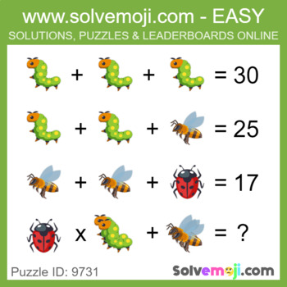  What is the value of the caterpillar, the bee and the ladybug?  Can you solve the last equation?
Spelling | Talking & Listening | Maths/Numeracy
Log in to Reading Wise and spend 15-20 minutes working through activities.  www.readingwise.com  On another post called ‘Spelling Challenge’ there will be attached a full list of your groups words and a Spelling Challenge card. Have a go at 2 or 3 of the spelling challenges of your choice.  Our sounds this week are ‘mb’ for Eagles, Penguins and Robins and ‘ock’ for Chicks.  You can also go to www.spellingcity.com/ and type in the spelling words for this week. Play the spelling games using these words or come up with your own words for these revision sounds. | Watch newsround each day and take notes of the main points and discuss.  https://www.bbc.co.uk/newsround | As Mrs Russell stated on the blog we will be trialing a new diagnostic test on Sumdog this week.  There are two parts to the test; one takes 15 minutes and the other one gives you an hour to complete it.  Please also have a look through the 3D Shape PowerPoint and work through the 3D worksheets provided.
Something fun! | Problem to solve! | Handwriting
Decide on a fun thing to do for 30 minutes with a family member. Ask them to join in. eg play a game. | Tickets for the latest film cost £5 each. Your family has £38 saved up. How many of you can go to the cinema to see the film? How much money will there be left over? | Please complete pages 18 & 19 in your Nelson Handwriting Workbook Starter C.
***** -

