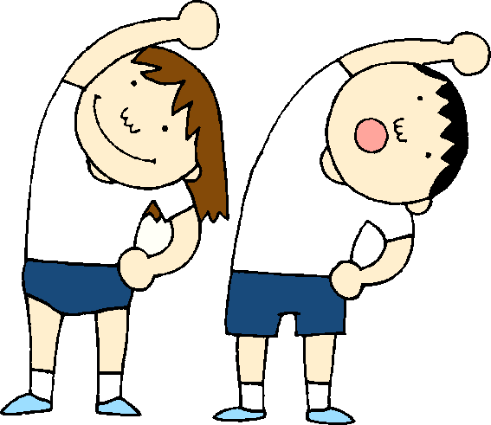Physical Exercise Assignment

Please have an adult read through this page with you before you get started.
Always remember to stretch before and after you have done any exercises!
Learning Intention:
We are learning that physical exercise plays an important role in keeping our bodies healthy.
Success Criteria:
We Will…
- Understand why we need physical exercise.
- Discuss the benefits of physical exercise.
- Discuss some of the ways that you can be active.
- Understand how much exercise we need every day to keep us healthy.
Activities and Instructions.
Before you complete the tasks:
- Look through The Physical Exercise Power Point.
- Choose from one of the activity cards to try. Don’t worry if you can’t cut anything out or stick anything together, you can ask someone else to choose an activity for you to try.
Discussion and Written Task:
- Talk to someone in the house about why they think exercise is important.
- Complete The Exercise Diary for the week.
- Create a poster encouraging people to get at least one hour of exercise every day.
Extra: Look at The Obstacle Course Worksheet and create your own obstacle course.

