Speech Marks Assessment Targets

Primary 4 Core Targets:

F3 | A  Did you put a capital letter at the start of your sentence and a full stop at the end? Have you used other punctuation ? ! | Does your writing make sense? | Have you written neatly? | 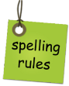 w-i-th  Did you spell most common words & tricky words correctly? | 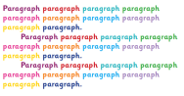  Did you use paragraphs to separate your ideas? | 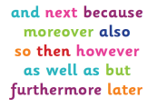  Did you join sentences together using ‘and, because, but, so’? | 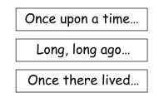  Did you change the length of your sentences and how they begin to make them interesting?
SA
PA

Primary 4 Recount Targets

I can... | You | Adult
- understand why I am writing and who will read my recount (audience and purpose)
- include a title to say what the recount is about
- write a paragraph which sets the scene, telling what your subject or event is (when, who, what where)
- write 2 or 3 paragraphs to describe the events in order
- write about people, places and dates
- use time connectives/conjunctions eg. next, then, soon, afterwards
- write in the past tense eg. was, were, had, saw ...The man was standing in the rain. He had red slippers on. Then he ran...
- include a final paragraph that sums up the recount
- use pictures, photos or labelled diagrams to show what happened
Speech Marks Targets
I can... | You | Adult
- Make sure the words within the speech marks are only words being spoken
- Use the correct punctuation – “ A .”
- Identify who is speaking e.g. “Good morning!” said Mrs Fairley.
- Begin to use words other than ‘said’ e.g. shouted, exclaimed, shrieked

