Mrs Russell’s garden
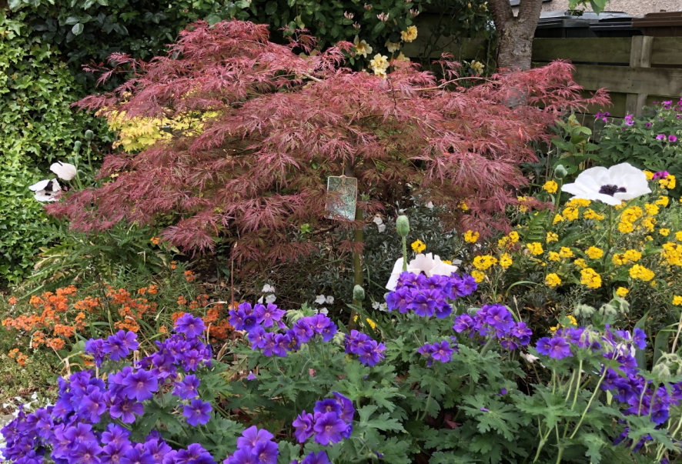
The little tree in the background is called a ‘maple’ .
The yellow flower is called a wallflower and come in lots of different colours.
The blue plant at the front is a blue geranium.
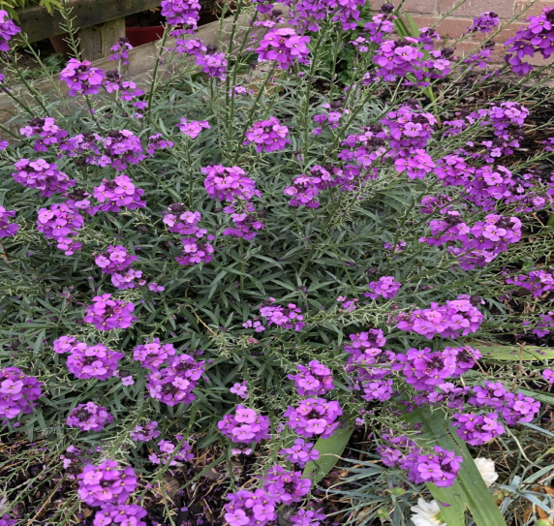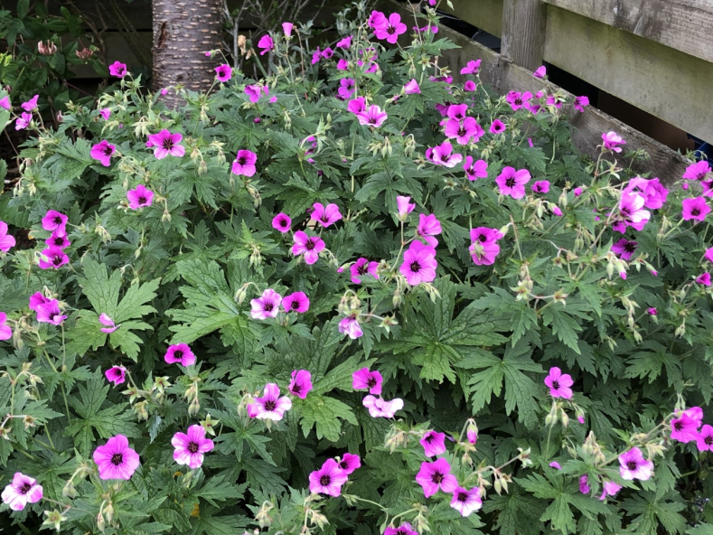
Purple wallflower. Pink geranium
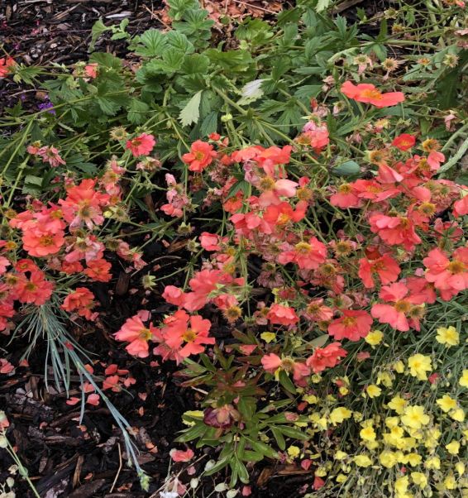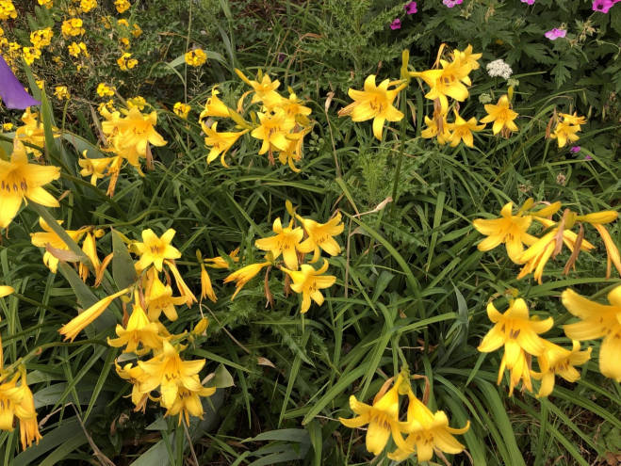
Orange geum Yellow lillies
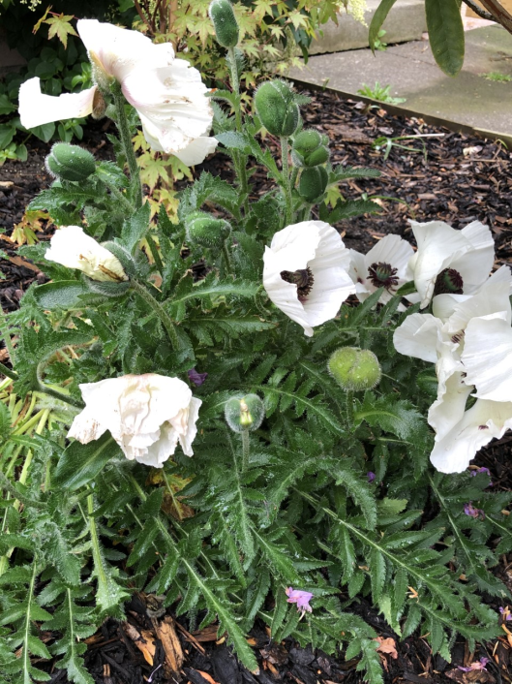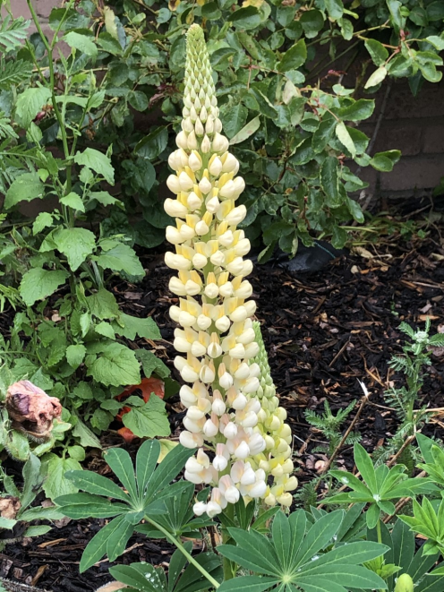
White poppy Lupin
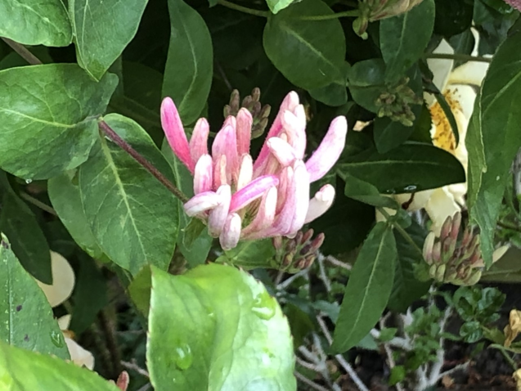 This honeysuckle is just about to flower. The bees love to collect pollen from it to make honey!
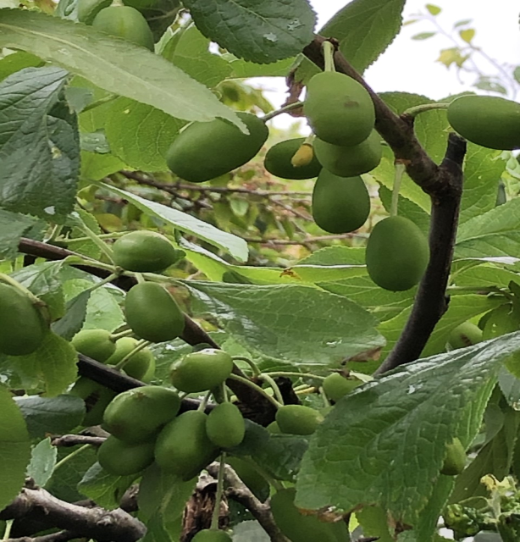
My plum tree should produce lots of fruit in August. Maybe I’ll be able to bring in some plums for you to try when we get back to school – if the birds don’t get them first!
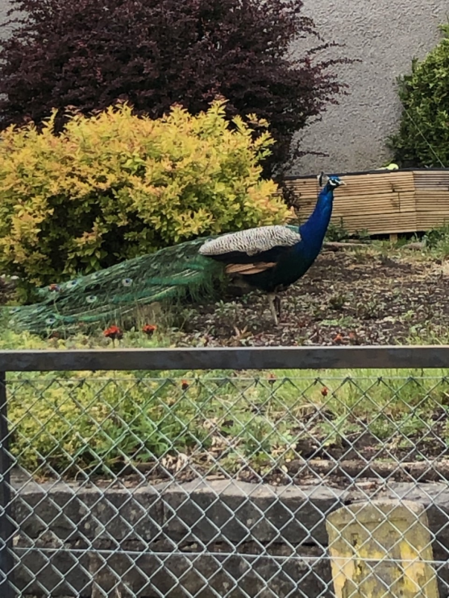
This is a photo of the cheeky peacock who has made his home in the village that I live in. He likes to wander up the street and have a look around everyone’s garden!!

