Week beginning – Mon 8th June = Priority Tasks


Reading  Complete the Martin Luther King comprehension task. There are 3 versions: mild (*), spicy (**) and hot(***).    Answer questions in full sentences and give reasons for your answers where appropriate.    *Remember to read the information and questions carefully and assess your answers using the core writing targets before submitting your assignments. | Writing  Racism Debate  If any of you have been watching the news recently you will have heard about people protesting against racism after the very sad death of George Floyd In the USA.  Look at the PowerPoint called Racism on your bus. It asks you to debate a number of questions. You could either have a discussion with your family or chat to your peers via the Collaboration Channel on Teams.  *Remember to debate means to share your thoughts and opinions, backing them up with reasons and or evidence.  There is a question sheet for you to complete and a poster for you to design.   | Numeracy  Times Table Focus Fortnight  Your main task this this week and next will involve practising the times tables using Sumdog. The appropriate level will already be set for you with an assessment as usual on Thursday and Friday of each week.  No assignment will be set on Teams, however we will be monitoring Sumdog use and using this information to plan further work    There is also a Times Tables folder on Teams in the Maths File which contains a variety of worksheets including Table Tastic and Mad Minute Maths if you want to do some work on paper. You do not need to submit these for marking. | Health and WellBeing  Embrace Our Differences  Look at the PowerPoint titled: Embrace Our Differences and think about all the ways we are different and how this can lead to discrimination.  This task is linked to your writing task therefore feel free to discuss your opinions with your family or via the Collaboration Channel.  Complete the activity sheet called We are all different.  There is also a spot the difference sheet just for fun ☺
Additional Activities  We have set specific skills for you to practise Monday to Wednesday on Sumdog Grammar and Spelling. These skills will be assessed on Thursday and Friday.   | Additional Activities  Think of your favourite character from either a book, TV, film or even a video game and create a cartoon strip of them on an adventure of your choice.  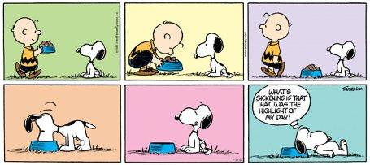 | Additional Activities  Do something kind for a family member or friend. For example: help with household chores, make them a card or bake a cake.  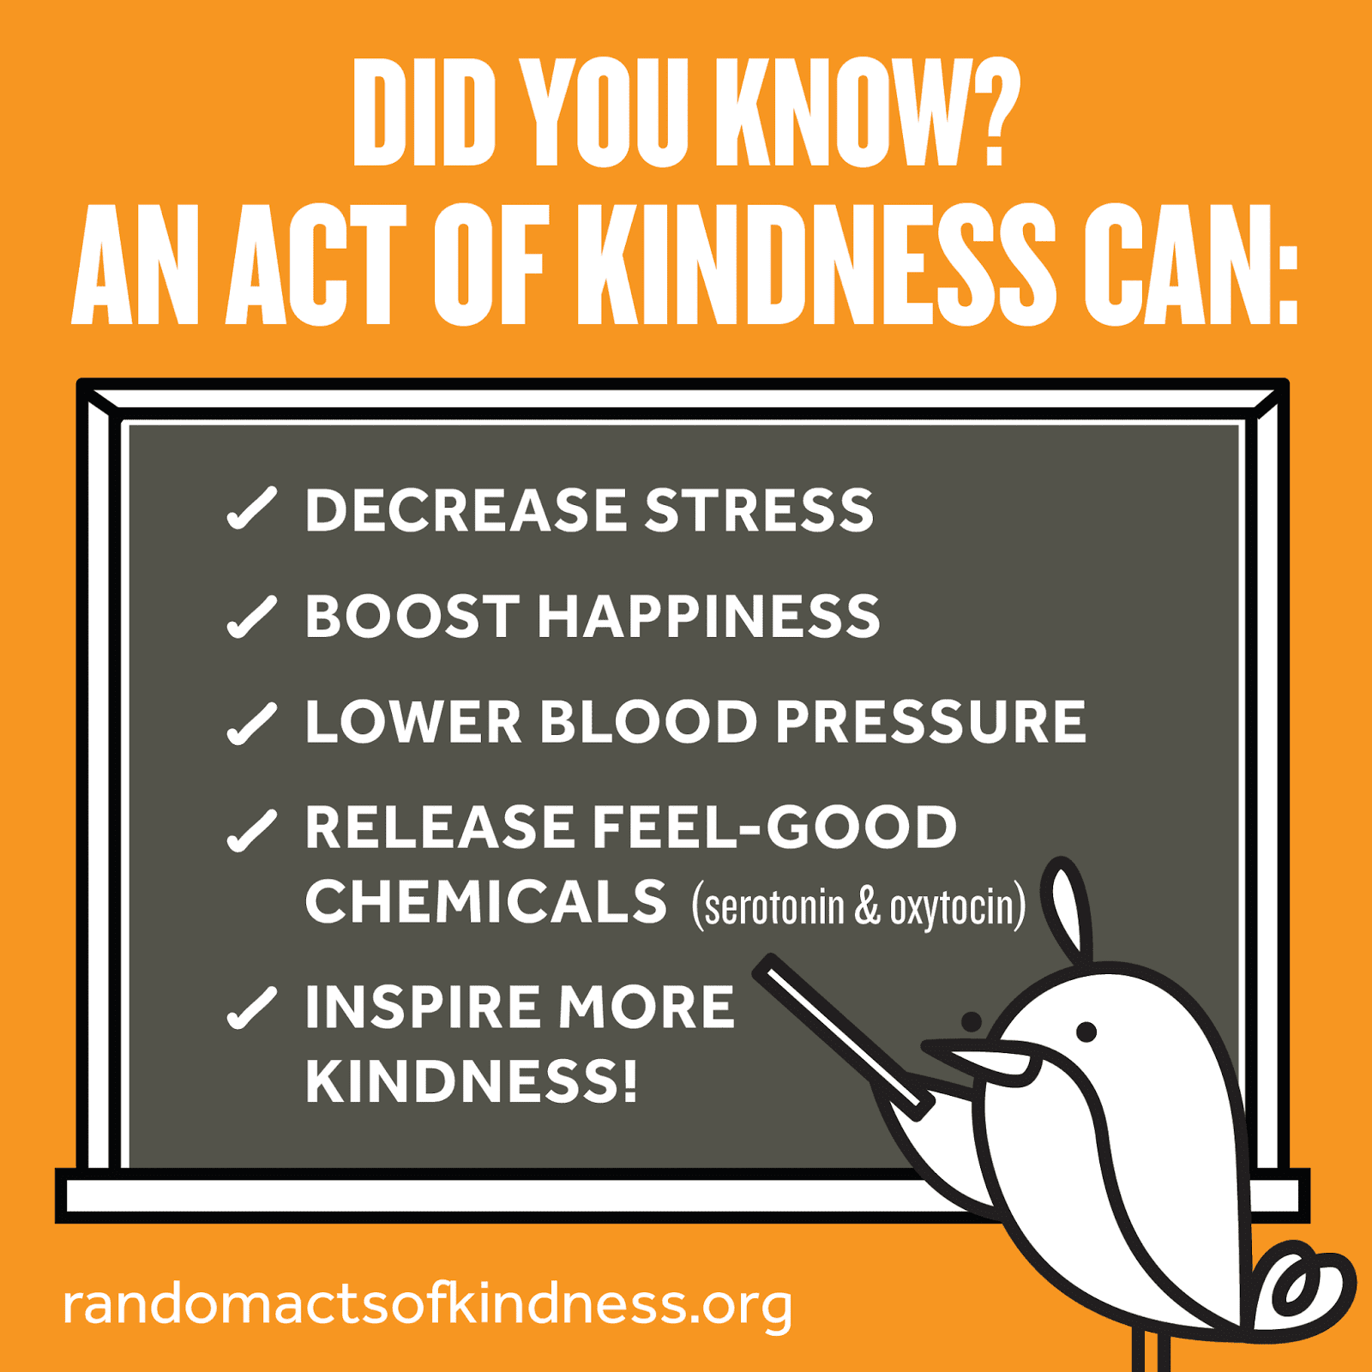 | Additional Activities  If you’re feeling bored why not try some of the 5 Minute Boredom Busters?  

Expectations
- The Learning Grid gives you a range of activities that can be completed each week. The tasks marked with a are priority tasks and we would ask you to complete them each week. These priority tasks may also be set as assignments in your class team on Glow in order that you can share your learning with your teacher and receive some feedback where appropriate. Sumdog is an important part of your learning because your teacher can clearly see your strengths and weaknesses and set work to suit your abilities.

