Primary 3 – Week 9 01/6/20 – 05/6/20
Writing | Reading | Number
Imagine a Setting  This is a scene from ‘Alice in Wonderland’.  The surroundings seem so big, making Alice appear even smaller.  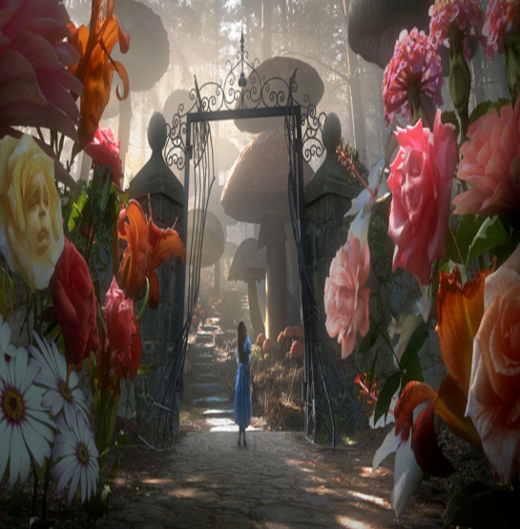  Imagine you were trapped in your school after you had been shrunk.  Describe your journey from the door across the classroom.  What dangers would you have to be careful of as a tiny person?  Challenge: Use a thesaurus to look up ‘big’ and ‘small’. What words can you find? | P3B  Dragonflies/Butterflies – Key Comprehension Book 1 – Unit 6 Page 18 & 19  Bees/Ladybirds/Caterpillars – ORT Booklet – Page 17 & 18  P3R  Apples – Key Comprehension Book 1 – Unit 6 Page 18 & 19  Bananas/Oranges/Pears - ORT Booklet – Page 17 & 18. | What is the value of the musical notes, the keyboard and the trumpet?  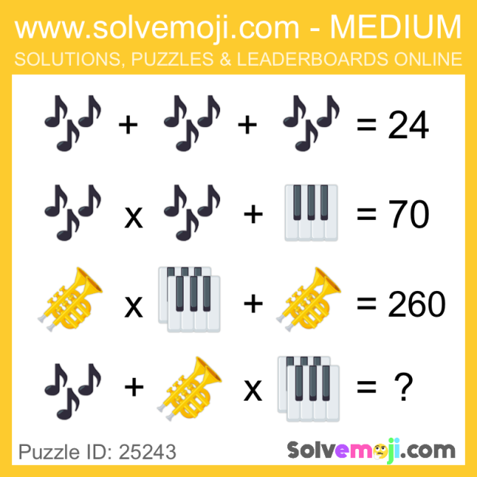
Spelling | Talking & Listening | Maths/Numeracy
Log in to Reading Wise and spend 15-20 minutes working through activities.  www.readingwise.com  On another post called ‘Spelling Challenge’ there will be attached a full list of your groups words and a Spelling Challenge card. Have a go at 2 or 3 of the spelling challenges of your choice.  Our sounds this week are ‘kn’ for Eagles, Penguins and Robins and ‘og’ for Chicks.  You can also go to www.spellingcity.com/ and type in the spelling words for this week. Play the spelling games using these words or come up with your own words for these revision sounds. | Watch newsround each day and take notes of the main points and discuss.  https://www.bbc.co.uk/newsround | On Sumdog there is a Revision Challenge for all maths groups. You have until this Friday 5th to complete.  Please also have a look through the Shape PowerPoint and work through the two worksheets provided.
Something fun! | Problem to solve! | Handwriting
Decide on a fun thing to do for 30 minutes with a family member. Ask them to join in. eg play a game. | There are two stacks of presents for Jack and Ashley. There are 15 presents in  one stack and 18 in another stack. How many presents in total are there?  Jack unwrapped two boxes of puzzles. There are 24 pieces of puzzles in each of  the boxes. How many puzzles pieces are there in total? Jack receives a box of Lego mini-figures. It comes with 12 mini-figures. He  already had 9 of them. How many Lego mini-figures does he have now? | Please complete pages 16 & 17 in your Nelson Handwriting Workbook Starter C.
***** -

