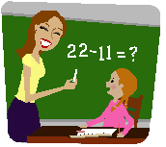 |  | 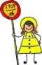

Name …………………………………… Date………………………………………
People who help us
Draw 4 people who help you in school. Write who they are.
.................................................. | ..................................................
.................................................. | ..................................................

