Primary 3 – Week 8 25/5/20 – 29/5/20
Writing | Reading | Number
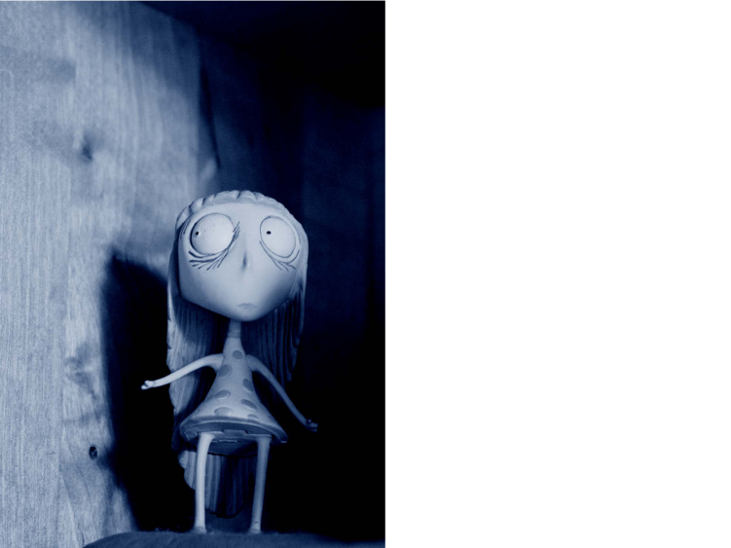  Understand a Character’s Point of View  This girl looks worried or scared.  1) Explain how we know this.  We know that this girl is worried because…  2) Ask her three questions.  What…?  How…?  Why…?  Challenge:  Ask an ‘if’ question. | P3B  Dragonflies/Butterflies – Key Comprehension Book 1 – Unit 6 Page 16 & 17  Bees/Ladybirds/Caterpillars – ORT Booklet – Page 15 & 16  P3R  Apples – Key Comprehension Book 1 – Unit 6 Page 16 & 17  Bananas/Oranges/Pears - ORT Booklet – Page 15 & 16. | What is the value of the branch, the rose and the Christmas tree?  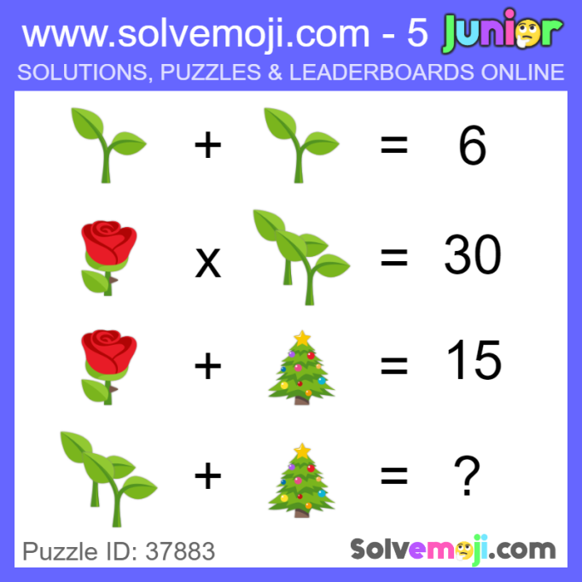
Spelling | Talking & Listening | Maths/Numeracy
Log in to Reading Wise and spend 15-20 minutes working through activities.  www.readingwise.com  On another post called ‘Spelling Challenge’ there will be attached a full list of your groups words and a Spelling Challenge card. Have a go at 2 or 3 of the spelling challenges of your choice.  We are revising our sounds from Week 5 (ss and ud), Week 6 (ll and ug) and Week 7 (ff and ud). See attached sheets.  You can also go to www.spellingcity.com/ and type in the spelling words for this week. Play the spelling games using these words or come up with your own words for these revision sounds. | Watch newsround each day and take notes of the main points and discuss.  https://www.bbc.co.uk/newsround | As always you can spend time on Sumdog, however this week take time to remind yourselves about number bonds using the topmarks site below.  https://www.topmarks.co.uk/maths-games/hit-the-button  There are differentiated multiplication worksheets for you to complete. I have put examples underneath some of the questions to help you.
Something fun! | Problem to solve! | Handwriting
Decide on a fun thing to do for 30 minutes with a family member. Ask them to join in. eg play a game. | Assembly starts at 10.15. It lasts for 30 minutes. What time does assembly finish?  Can you write it in digital time and analogue time? | Please complete pages 14 & 15 in your Nelson Handwriting Workbook Starter C.
Science
Fireworks in a glass
See attached for a fun experiment of how to make fireworks in a glass at home.
***** -

