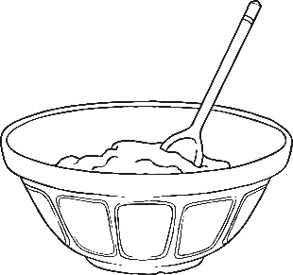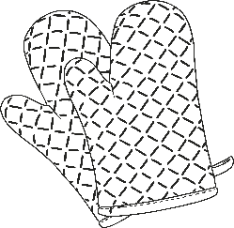

# How to make a

# Writing Instructions

# Equipment

# Ingredients

# Method