
Hot - Angles as Degrees of Turn
- Start facing north. Follow the directions to sail safely across the ocean. Colour in your path.
Finish
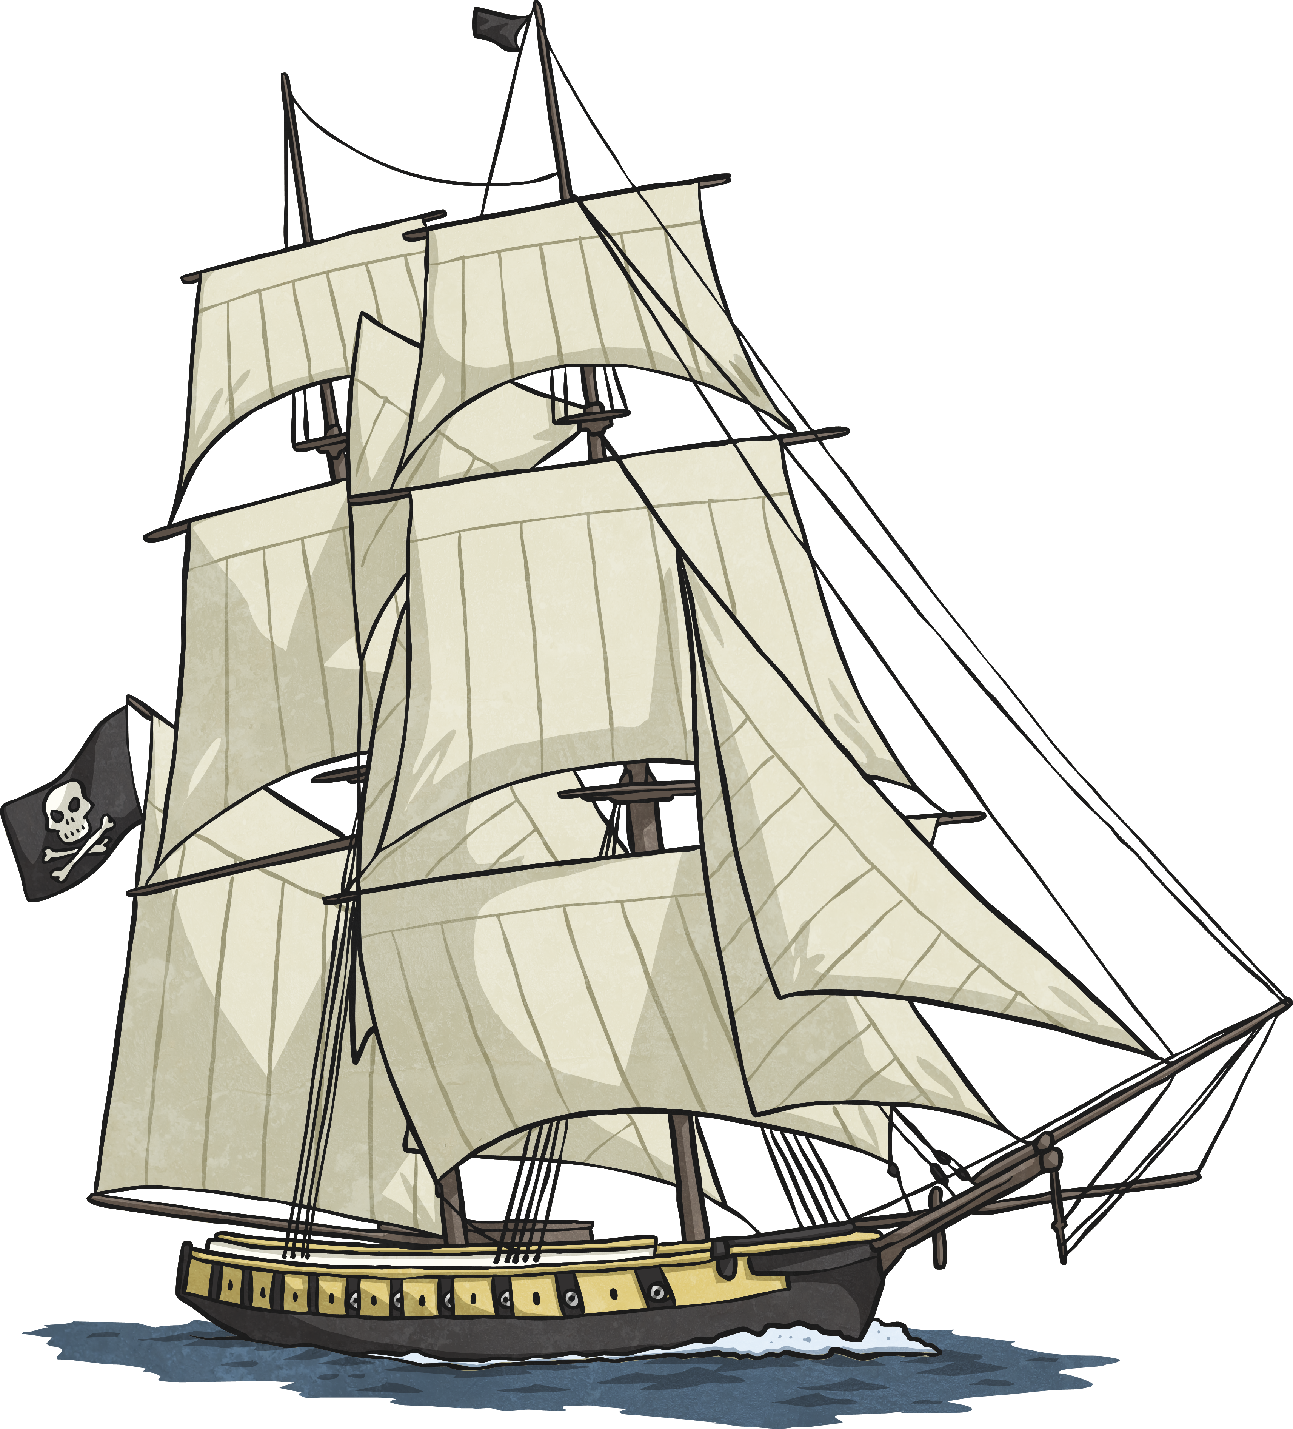
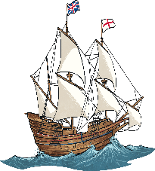
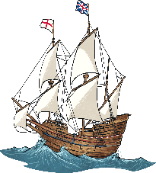
Start

- Forward 1
- Turn 270º clockwise
- Forward 3
- Turn a right angle clockwise
- Forward 2
- Turn ¼ anticlockwise
- Forward 3
- Turn 270º clockwise
- Forward 3
- Turn 90º clockwise
- Forward 1
- Turn ¾ anticlockwise
- Forward 4
- Turn east
- Forward 1
- Turn north
- Forward 2
- Turn 90º anticlockwise
- Forward 1

- Can you write the directions which will allow safe passage across this dangerous sea and avoiding ships? You can move diagonally.

Finish
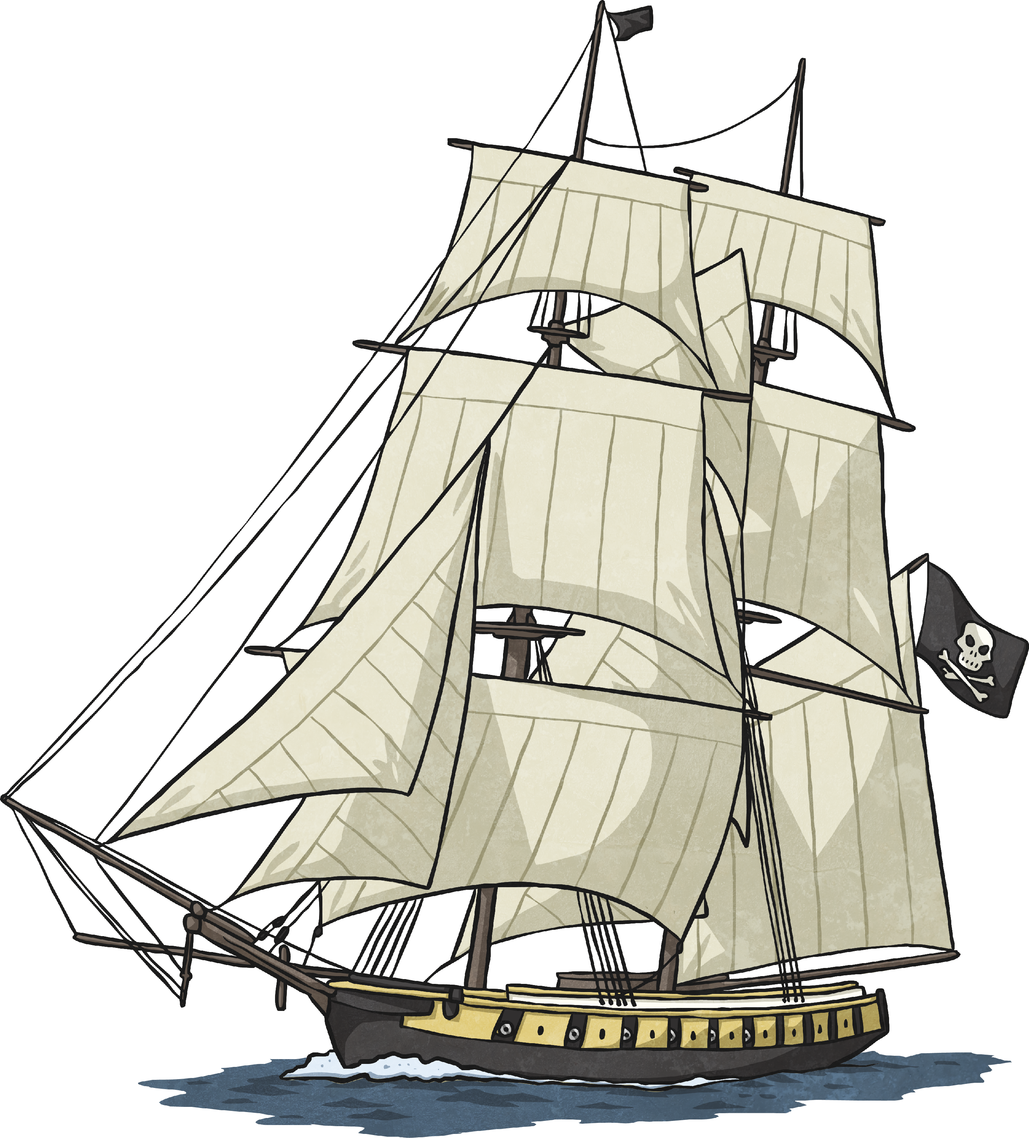
Start

Write your instructions in here, and remember to number the steps.

Additional space for instructions.

