Primary 3 – Week 7 18/5/20 – 22/5/20
Writing | Reading | Number
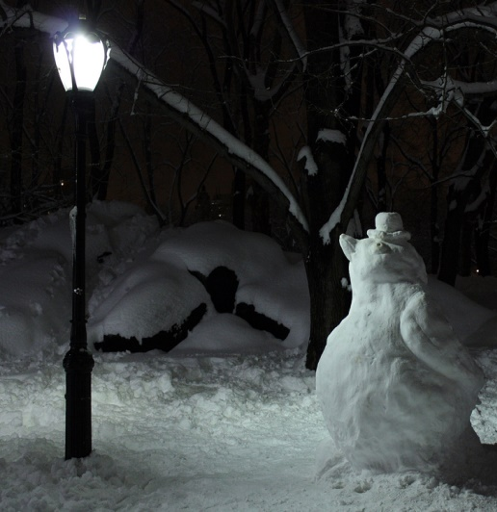  Describe a Setting  Write 5 sentences about:  - What you can feel under your feet  - What you can see  - What you can hear  - What the weather is like  - Your footprints  Challenge:  Imagine the penguin comes to life. Describe the moment when it realises it can move. Describe it moving gently and carefully at first. Describe what it decides to do. | P3B  Dragonflies/Butterflies – Key Comprehension Book 1 – Unit 6 Page 14 & 15  Bees/Ladybirds/Caterpillars – ORT Booklet – Page 13 & 14  P3R  Apples – Key Comprehension Book 1 – Unit 6 Page 14 & 15  Bananas/Oranges/Pears - ORT Booklet – Page 13 & 14. | What is the value of the egg cup, the nest and the three eggs?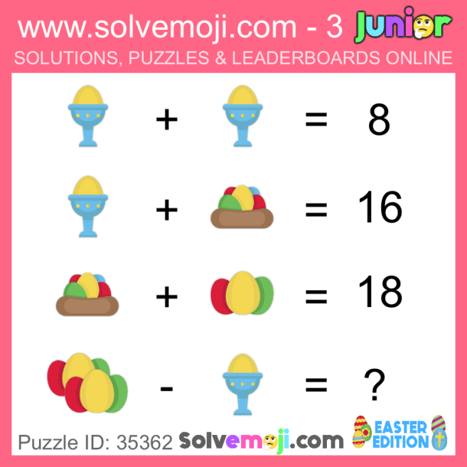  Take part in the West Lothian Sumdog competition.
Spelling | Talking & Listening | Maths/Numeracy
Log in to Reading Wise and spend 15-20 minutes working through activities.  www.readingwise.com  On another post called ‘Spelling Challenge’ there will be attached a full list of your groups words and a Spelling Challenge card. Have a go at 2 or 3 of the spelling challenges of your choice.  Our sounds this week are ‘ff’ for Eagles, Penguins and Robins and ‘ud’ for Chicks.  You can also go to www.spellingcity.com/ and type in the spelling words for this week. Play the spelling games using these words or come up with your own words for these revision sounds. | Watch newsround each day and take notes of the main points and discuss.  https://www.bbc.co.uk/newsround | Complete differentiated pattern worksheet.  Remember, multiplication is repeated addition. Work out the difference between each of the given numbers and try to continue the pattern.
Something fun! | Problem to solve! | Handwriting
Decide on a fun thing to do for 30 minutes with a family member. Ask them to join in. eg play a game. | Assembly starts at 10.15. It lasts for 30 minutes. What time does assembly finish?  Can you write it in digital time and analogue time? | Please complete pages 12 & 13 in your Nelson Handwriting Workbook Starter C.
***** -

