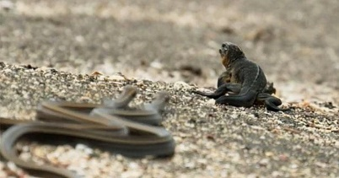
Snakes vs Iguanas- Planet Earth II

https://www.youtube.com/watch?v=Rv9hn4IGofM&feature=emb_title
Pause the clip at the given moments and either think about or discuss the questions at home. Once the clip is finished, choose either a mild, spicy or hot writing activity to complete!
If you are unable to access the video please see the information below. Our mild writing challenge can be completed using this alone.
‘The iguana, a mere hatchling, instinctively stays still at first, hoping to elude detection, but when it becomes clear that the snake is going to strike, the iguana starts running, and racer snakes pour out of cracks in the rocks along the beach, joining the chase.
It is unnerving to watch, and it looks like the poor iguana is doomed when it gets tangled up in a bunch of snakes, but the reptile wriggles out of the cluster and scurries up the rocks, making a dramatic leap to safety as one snake lunges—its mouth wide open—in a failed last-ditch effort to catch its prey.’
Learning Intention:
We are learning how to watch and listen to a variety of texts.

Discussion: | 13 seconds | What do you think this is about? Why has the director chosen to place the camera  behind the snake?
 | 29 seconds | What is the snakes’ eyesight like? How does it find its prey?
 | 43 seconds | Watch the snake’s tail disappear out of shot. What impression does this give you about the snake? What else gives you that impression?
 | 59 seconds | How does the music change? Why is this?
 | 1 mins 15 seconds | How has the music changed again? Why is this?  Why do the snakes hunt in packs?
 | 1 mins 30 seconds | How do these snakes kill their prey? What do you think is going to happen?
 | 1 mins 54 seconds | Parts of this clip are in slow motion. Why?
Thinking: |  | -At the end, the narrator says, “A near miraculous escape.” What does this mean?  -What type of television programme is this clip from? How do you know?  - Where do you think this clip is set?  - Who is the intended audience of this programme?  - Why do you think this clip shows the iguana escaping instead of being caught?
Writing: | Mild | Write down:  -Five adjectives to describe the snakes.  -Five adjectives to describe the iguana.
 | Spicy | -Re-watch this clip and turn the sound off. Can you write the voiceover for this video?  Think about how your sentences could inform the viewer about these amazing creatures but also add tension to keep your audience hooked!
 | Hot | -Create a fact file about either a Snake or Iguana.  Include (Success Criteria):  -A picture of your chosen reptile.  -A short description of their habitat.  -Three interesting facts.

