Outdoor Art
Think about the plants and flowers you see when you are playing in the garden or going for a walk.
Look closely; check all the small, delicate details the flower, leaf or plant has.
What can you see - petals, leaves, veins, different colours, long/short stems?
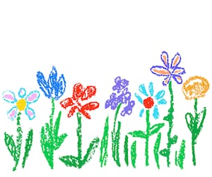
This week, we would like you to draw a flower, plant or a leaf. Try and draw everything you see, the more you add the more detailed and life-like the drawing will be.
You can use any type of art and craft material to design your flower/plant/leaf - pencil, pen, paint or cut out paper.
If you need a little support, here are a few videos to help.
- How to draw a tulip
https://www.youtube.com/watch?v=zY1269CaCFk
- How to draw a daisy
https://www.youtube.com/watch?v=TMYhplLC9oo
- How to draw a leaf
https://www.youtube.com/watch?v=5PlWnH1TCG0

