
Spicy - Angles as Degrees of Turn
- Start facing north. Follow the directions to sail safely across the ocean. Colour in your path.
Finish
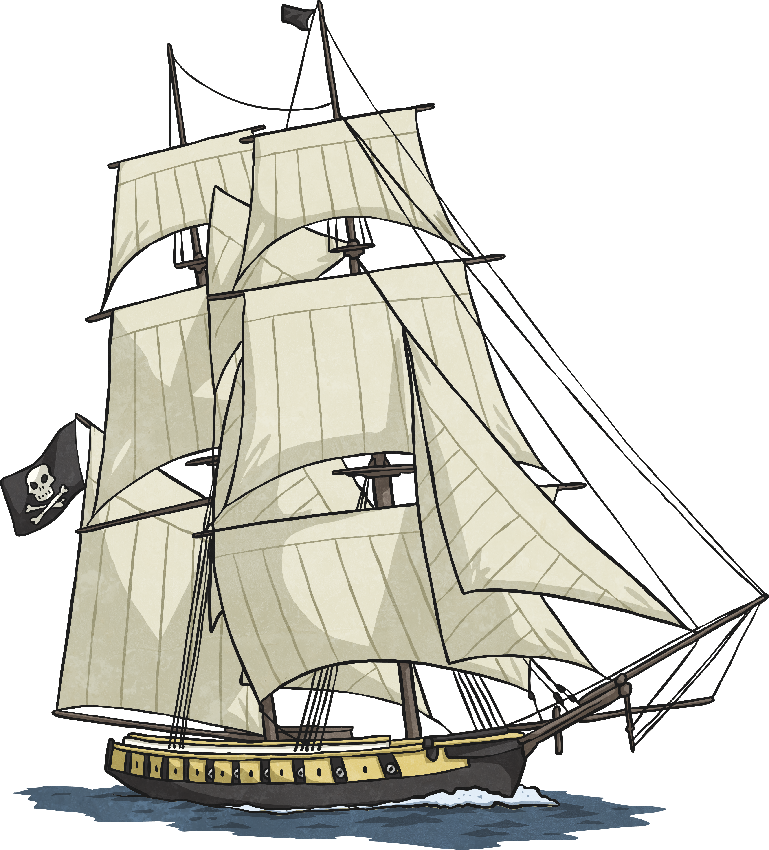
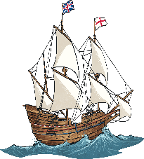
Start

- Turn to face east.
- Forward 5.
- Turn ¾ clockwise.
- Forward 3
- Turn 90º anticlockwise.
- Forward 4.
- Turn to face north.
- Forward 3.
- Turn 90 º anticlockwise.
- Forward 3.

- Can you write the directions which will allow safe passage across this dangerous sea and avoiding ships?

Finish
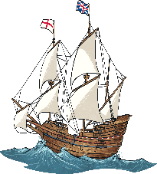
Start

Write your instructions in here, and remember to number the steps.

Additional space for instructions.

