
Mild - Angles as Degrees of Turn
- Start facing north. Follow the directions to sail safely across the ocean. Colour in your path.
Finish
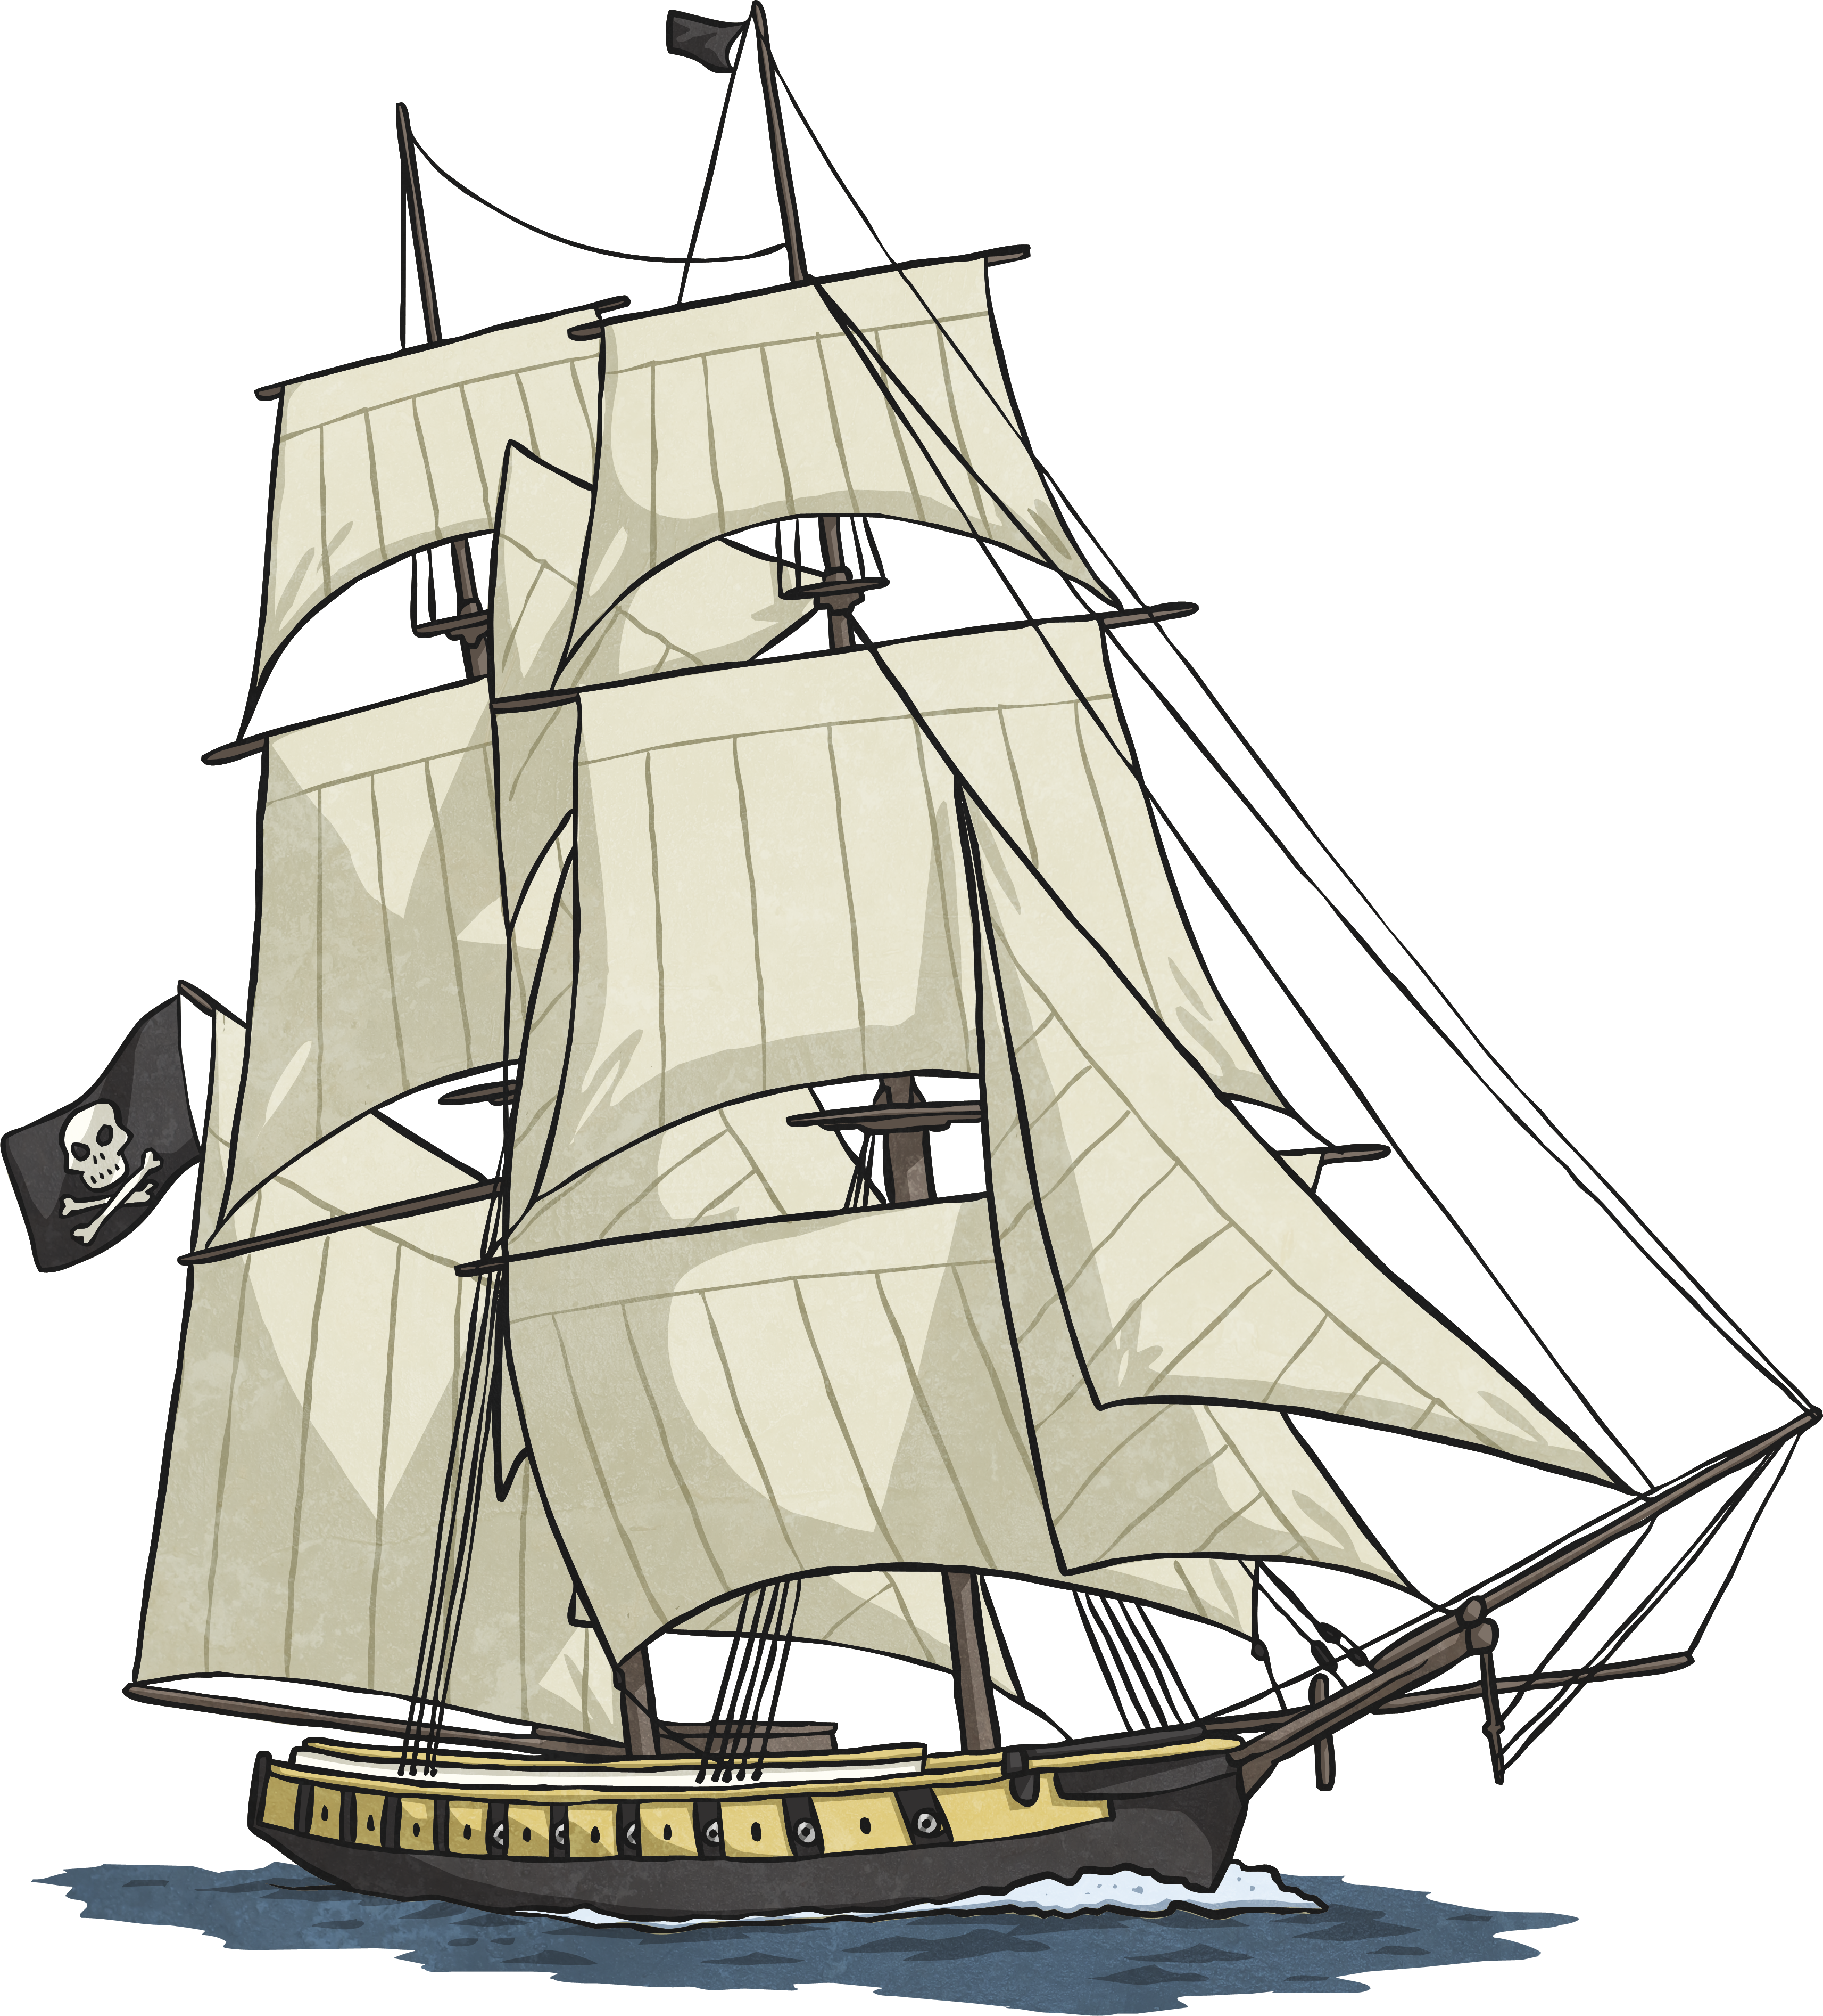
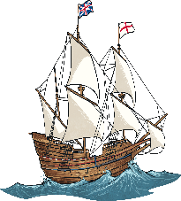
Start

1. Forward 2 squares
7. Forward 3 squares
2. Right angle turn clockwise

8. Right angle turn anticlockwise
3. Forward 2 squares
9. Forward 2 squares
4. Turn 90 degrees anticlockwise
10. Three quarter turn clockwise
5. Forward 2 squares
11. Forward 7 squares
6. Three quarter turn anticlockwise
- Can you write the directions which will allow safe passage across this dangerous sea?

Finish
Start
1.
10.
2.
11.
3.
12.
4.
13.
5.
14.
6.
15.
7.
16.
8.
17.
9.

