See Saw Up and Down Instructions
First
Sing and clap beat (4 beats per line/ 8 total)
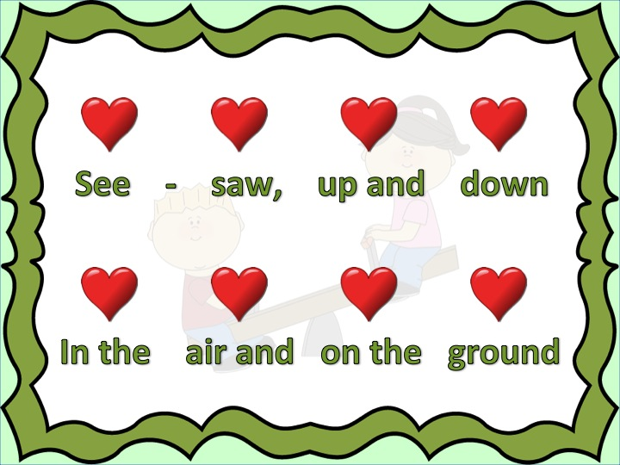
Next
Look at rhythms through the word syllables
1 image = 1 beat (slow) = 1 line or crotchet
2 small images = 2 half beats (quick) = 2 lines or quaver
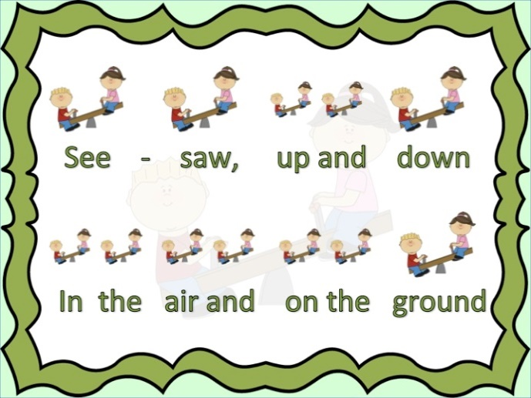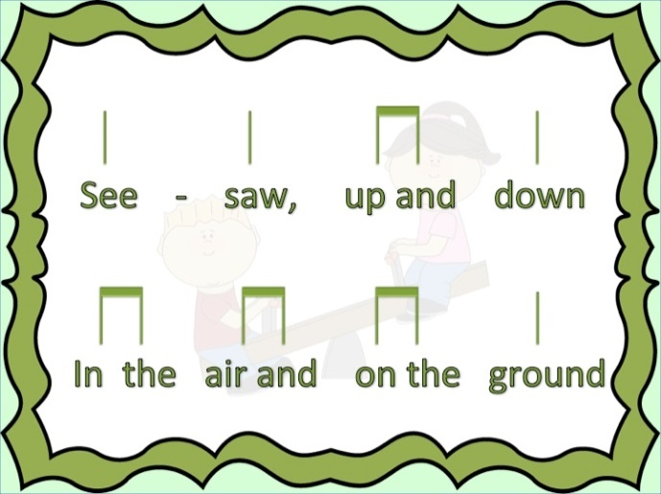
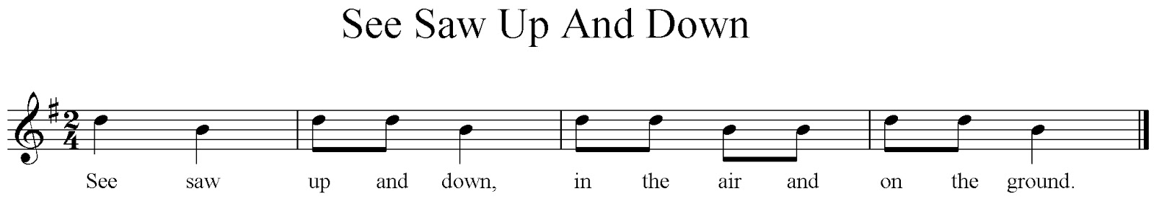
Finally
Complete worksheet by drawing or cutting and sticking Kodaly rhythm note shapes
(line or double line)

