Kodaly music notes values

NOTE | SOUND | BEAT
Semibreve | TO-o-o-o | Play 1 beat – Lasts 4 Beats  Whole Note
Minim | TO-o | Play 1 beats – Lasts 2 Beats  Half Whole Note
Crotchet | Ta | Play 4 beats – Lasts 1 Beat  Quarter Whole Note
Quaver | Ti-Ti | Play 8 beats – Lasts a 1/2 Beat  8th Whole Note
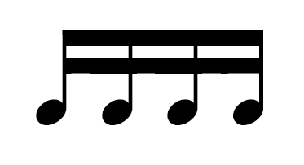  Semi Quaver | Tiki-Tiki | Play 16 beats – Lasts a 1/4 Beat  16th Whole Note

