Crotchet Note: ONE sound on one beat  We say, “Ta” | Quaver Note: TWO sounds  on one beat  We say, “TiTi”
Crotcher and Quaver Note: THREE sounds lasting two beats
We say, “TiTi Ta”

Directions: Cut out the pictures. Clap and say the picture. If it is a one-clap word, glue it in the crotchet note box. If it is a two-clap word, glue it in the quaver note pair box. If it is a three clap word, glue it in the crotchet and quaver note box.

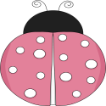  Ladybug |   Flower | 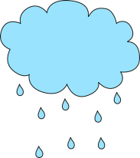  Rain
  Butterfly | 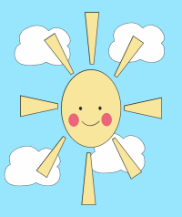  Sunshine | 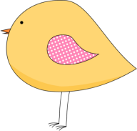  Bird

