L.I. To plot coordinates onto a graph
Success Criteria
I can plot coordinates in four quadrants
I can mark the point with an x
I can join the x’s to make a shape
I can name the shape
Remember, always go along the deck before you go up the flagpole (or down) the anchor!

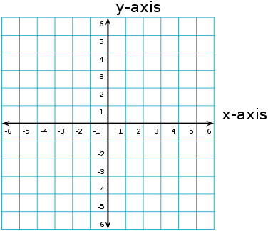

( 1 , 4 )
( 3, 1 )
( -1, 1 )
Shape_____________________

( 4, 3 )
( 4, -5 )
( -1, -1 )
Shape_____________________

( -2, -3 )
( -4, -3 )
( -4, 2 )
Shape_____________________

( 3, 3 )
( 3, -3 )
( -3, -3)
( -3, 3 )
Shape_____________________

( 1, 4 )
( 5, 1 )
( 2, -1 )
( -2, 2 )
Shape_____________________

( 0, 3 ) ( 2, 3 )
( 4, 1 ) ( 4, -1 )
( 2, -3 ) ( 0, -3 )
( -2, -1) ( -2, 1 )
Shape_____________________
Looking for an extra challenge?
Draw a grid, with axis labelled -5 to 5, draw your own shape and list the coordinates. Then swap with a partner to see if they can spot it!

