L.I. To plot coordinates onto a graph
Success Criteria
I can plot coordinates
I can mark the point with an x
I can join the x’s to make a shape
I can name the shape
Remember, always go along the cloakroom before you go up the stairs!

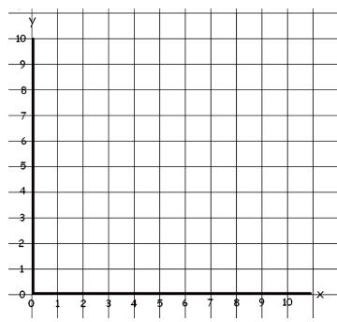

( 1 , 4 )
( 6, 8 )
( 7, 2 )
Shape_____________________

( 3, 2 )
( 6, 8 )
( 9, 6 )
Shape_____________________

( 9, 9 )
( 9, 1 )
( 4, 1 )
Shape_____________________

( 2, 3 )
( 5, 1 )
( 9, 4)
( 6, 6 )
Shape_____________________

( 2, 1 )
( 8, 1 )
( 8, 7 )
( 2, 7 )
Shape_____________________

( 4, 1 ) ( 6, 1 )
( 8, 3 ) ( 8, 5 )
( 6, 7 ) ( 4, 7 )
( 2, 5 ) ( 2, 3 )
Shape_____________________
Looking for an extra challenge?
Draw a grid, with axis labelled 0-9, draw your own shape and list the coordinates.

