Finding Fractions of Amounts 3

By now you should have completed 2 assignments on fractions of amounts and should now know the process of how to do it. This week we will be practising this in order for you to be confident in your learning. You are not expected to complete this entire assignment in one day as there are a few different tasks. It is far more important for you to make sure you understand what we are learning.

Learning Intention:
We are learning to find a fraction of an amount.

Success Criteria: We will…
- Know the role of the numerator and denominator.
- Use division to split our total number into equal parts.

Instructions:
If you are still unsure of how to find fractions of amounts, please look back at last week’s assignment. The videos on the White Rose Maths website should be particularly useful.

Warm Up Task:
Have a go at this game from Greg Tang Maths: https://www.gregtangmath.com/satisfraction
Click the ‘Identify’ option:
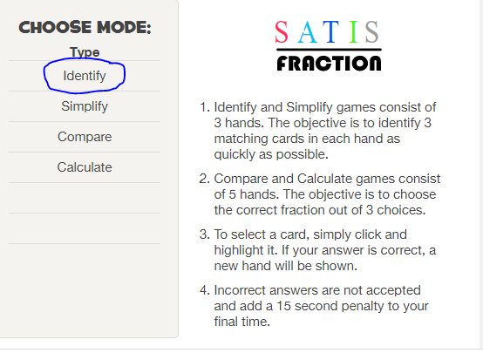

Main Task:
- Complete the Fractions of Money Worksheet. You can choose your difficulty level (*= mild, ** = spicy, *** = hot). The answers are available to support an adult or for you to check your answers and self assess. If you have made any mistakes please make sure you know where you have gone wrong before completing the next task.

- Complete the Fractions of Amounts Worksheets. Remember to use the denominator to divide!

- If you are finding both of these tasks a little tricky you can give the Fractions of Amounts – Mild a go. This includes easier examples with objects drawn out for you.

Challenge/Fast Finisher Task:
Watch Amber’s brilliant explanation of how to find fractions of amounts: https://www.youtube.com/watch?v=PgrF1TYXP6Y

Can you teach someone at home to find fractions of amounts just like Amber? You could even film your ‘lesson’ and upload it to our teams page!

