Week starting – Mon 11th May = Priority Tasks


Reading  Complete Scotland’s Landscape comprehension task. There are 3 versions: mild (*), spicy (**) and hot(***).  Answer questions in full sentences and give reasons for your answers where appropriate.  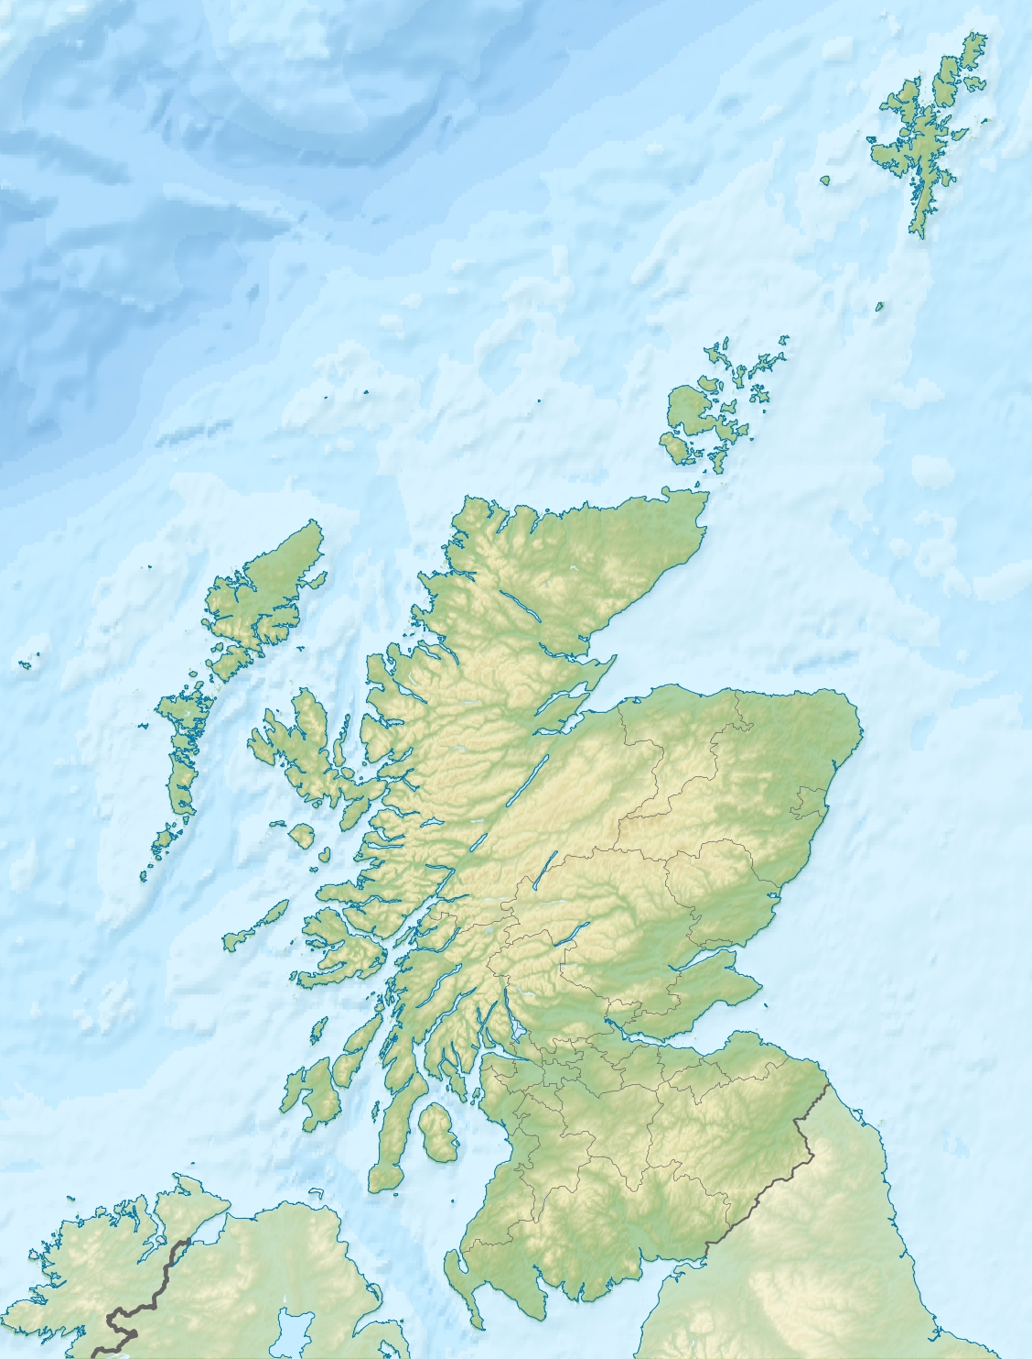  *Remember to read the information and questions carefully and assess your answers using the core writing targets. | Writing  Natural Disaster Information Report  You will have 2 weeks to complete this task. Research and write an information report about a type of natural disaster of your choice. You can carry out your own research using the internet, books (if you have any) and you will find PowerPoints with lots of information in the weekly resources folder in Teams and on the blog.  Use the information report genre and core writing targets to help you and to assess your work. Think back to when we wrote our reports about endangered animals and remember this is a factual report so it should not include any thoughts and feelings.   | Numeracy  Complete the time worded problems. There are 3 versions of this task: mild, spicy and hot for those who want to challenge themselves.    *Remember to use the RUCSAC method.  **Be careful, think about how many minutes are in an hour, hours in a day etc.   | Health and WellBeing  SHANARI Challenge  Draw an image to show what all of the wellbeing indicators mean to you. 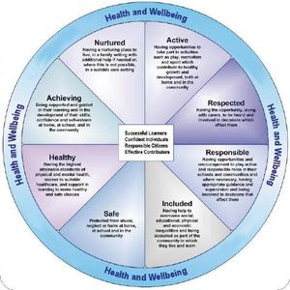  There is also a word search to complete for fun.
Additional Activities  We have set specific skills for you to practise on Sumdog Grammar and Spelling. These skills will be assessed on Thursday and Friday via Sumdog. | Additional Activities  Have a look at the daily lessons on BBC Bitesize  https://www.bbc.co.uk/bitesize/dailylessons | Additional Activities  We have set specific skills for you to practise on Sumdog Maths (addition and subtraction). These skills will be assessed on a Thursday and Friday via Sumdog. | Additional Activities  Try to complete a workout every day for example Joe Wicks or Cosmic Yoga.

Expectations
- The Learning Grid gives you a range of activities that can be completed each week. The tasks marked with a are priority tasks and we would ask you to complete them each week. These priority tasks will also be set as assignments in your class team on Glow in order that you can share your learning with your teacher and receive some feedback where appropriate.

