Primary 3 – Week 5 4/5/20 – 8/5/20
Writing | Reading | Number
Exposition - Persuasive  Write about why it is good to get out for one walk a day.  Even if you don’t go for one walk a day or cant. You are writing to persuade someone to do this.  Think about why it is good to get out for a walk?  Healthy? Why?  Fun? How?  Emotions?  What do you see?  Remember all your sentence rules. | P3B  Dragonflies/Butterflies – Key Comprehension Book 1 – Unit 5 Page 10 & 11  Bees/Ladybirds/Caterpillars – ORT Booklet – Page 9 & 10  P3R  Apples – Key Comprehension Book 1 – Unit 5 Page 10 & 11  Bananas/Oranges/Pears - ORT Booklet – Page 9 & 10. | 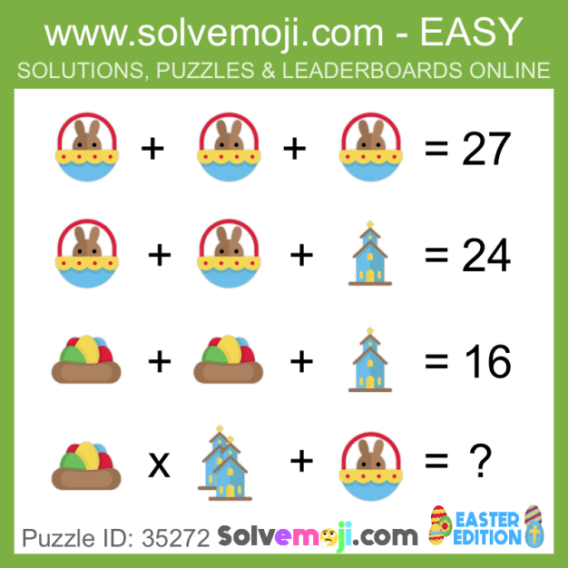  What is the value of the bunny, the eggs and the church?
Spelling | Talking & Listening | Maths/Numeracy
Log in to Reading Wise and spend 15-20 minutes working through activities.  www.readingwise.com  On another post called ‘Spelling Challenge’ there will be attached a full list of your groups words and a Spelling Challenge card. Have a go at 2 or 3 of the spelling challenges of your choice.  Our sounds this week are ‘ss’ for Eagles, Penguins and Robins and ‘ub’ for Chicks.  You can also go to www.spellingcity.com/ and type in the spelling words for this week. Play the spelling games using these words or come up with your own words for these revision sounds. | Watch newsround each day and take notes of the main points and discuss.  https://www.bbc.co.uk/newsround | Sumdog Multiplication Assessments relevant to your group – Squares, Triangles or Circles.  Log in and complete assessment task by the end of the week.  Try to spend at least 10 – 15 minutes a day on sumdog games.
Something fun! | Problem to solve! | Handwriting
Decide on a fun thing to do for 30 minutes with a family member. Ask them to join in. eg play a game. | Miss Buchanan saved 15p a week for one year. How many pounds did she save?  Mrs Russell saved 57p a month for one year. Did Mrs Russell save more than Miss Buchanan? | Please complete pages 8 & 9 in your Nelson Handwriting Workbook Starter C.
Art | Science
Draw a picture of your favourite walk. Use different materials if you can. e.g paint, pencils, pastels. | Before lock down we looked at why it was essential we wash our hands.  In this experiment we are going to look at how soap works and why it is better than just washing with water.  Fill out the Experiment Record Sheet whilst conducting the experiments.  Links to Why Soap Works Experiments and the Record Sheet are on the blog.
***** -

