Comprehension-Inference
Throughout Primary 6 and 7 we have been working on our ‘Reading Toolkit’. One of the tools we have used regularly to help us understand texts is ‘inference’. I have attached a powerpoint and information sheet for you to have a look at all about this.
Below is a comprehension for you to complete based on the song ‘Rewrite the Stars’. Use your inference skills to complete the questions in full sentences. You can either use a separate word document or feel free to edit this one and add your answers below.
QR codes are included for you to access the song however I have included the link below:
https://www.youtube.com/watch?v=RI-HOQ27QEM

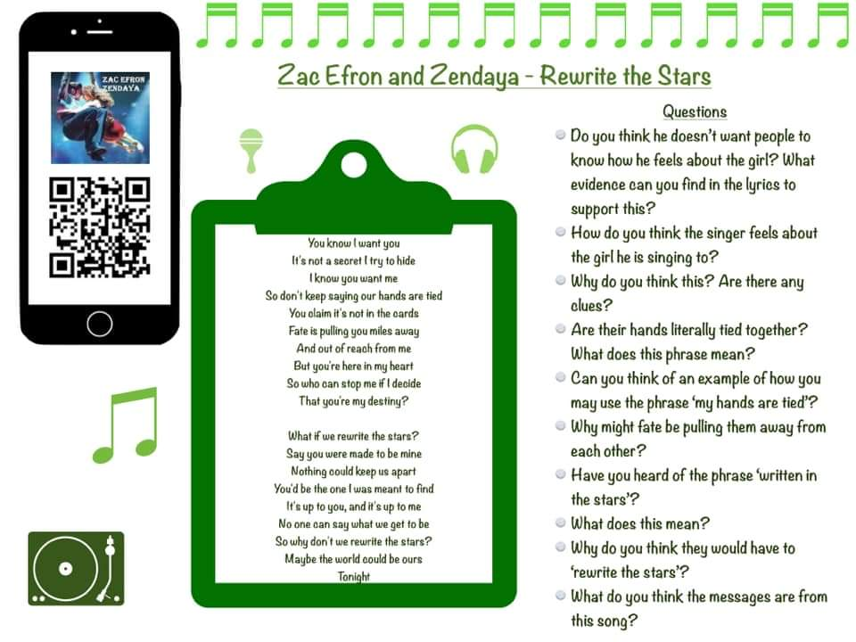
Answers:

