Continuity of Learning at Harrysmuir in Primary 4, 5, 6 and 7

- A weekly learning grid will be created and shared on both Teams and on the Learning Blog.
- We will set some priority tasks to be completed each week – reading, writing, numeracy and health and wellbeing.
- Where possible and appropriate, these priority tasks should be differentiated.
- Priority tasks should be set as assignments on Teams so that work can be uploaded by the children and feedback given.
- Additional tasks will be added to the grid for the week, some of which may last more than a week, which cover other areas of the curriculum. Eg, Topic, Art, RME, other Literacy, other Numeracy, etc. Where appropriate, work produced by our children can be uploaded to Teams.
- A folder will be added to each Team for each week so that the specific resources for activities can be stored there and will be easier to find on that specific week.
- Grid and linked resources should be posted by Monday morning in order that paper copies can be arranged for children who are collecting work rather than engaging online.
Week starting – Mon 27th April = Priority Tasks

Reading  Complete the Mars comprehension task. There are 3 versions: mild (*), spicy (**) and hot(***). Remember to answer questions in full sentences and give reasons for your answers where appropriate.    Remember to read the information and questions carefully and assess your answers using the core writing targets. | Writing  Research project  You will have 2 weeks to complete this task. Research a subject that you are particularly interested in and you can choose how to present your findings by creating; a poster, leaflet, written report or even a power point presentation.  This is your chance to use your research skills to share something that you are passionate about. Whether that is a hobby, country, animal, famous person or landmark. We will leave the subject up to you ☺  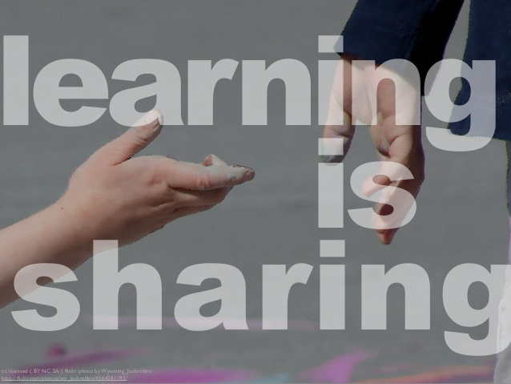  Remember to assess your writing using the core writing targets. | Numeracy  Complete multiplication worded problems.  There are 4 versions of this task: mild, spicy, hot and extra hot for those who want to really challenge themselves.  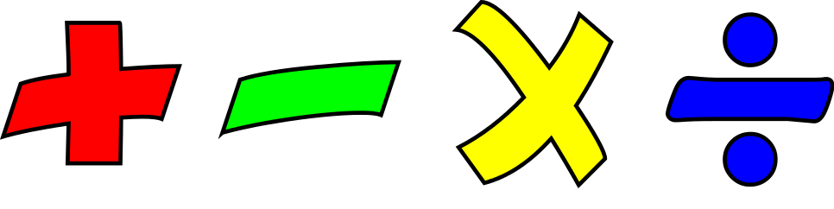  Remember to use the RUCSAC method:  R- read the question carefully  U- underline or take note of the important information in each question.  C- decide which calculation to use.  S- solve your calculation.  A- write the answer.  C- check your answer is correct and that you have answered all of the question. | Health and WellBeing  Fitness Diary  Although we are being asked to stay at home and keep ourselves safe, physical exercise is still very important. Keep a diary this week to record all the things you are doing to keep moving.  
Additional Activities  Unfortunately we did not get to go our trip to the museum to learn about natural disasters so Mr Blackwood has uploaded a PowerPoint and worksheets about volcanoes in the topic folder. | Additional Activities  Have a look at the daily lessons on BBC Bitesize  https://www.bbc.co.uk/bitesize/dailylessons | Additional Activities  Remember to keep working on Sumdog. Mr Blackwood and I will be regularly setting new challenges. | Additional Activities  Get involved in baking or cooking at home or write a recipe that you would like to try.  Keep in touch on the Chat Cannel and tell us about all the other things you are learning/doing to stay busy.

Expectations
- The Learning Grid gives you a range of activities that can be completed each week. The tasks marked with a are priority tasks and we would ask you to complete them each week. These priority tasks will also be set as assignments in your class team on Glow in order that you can share your learning with your teacher and receive some feedback where appropriate.

