P4 Suggested Activities Week 3.
Week Beginning 20/4/20
Maths
- There has been a Maths assignment set for you to complete in the Assignments section. This is on Fractions.
- In the Maths folder there is a Picture Sudoku for you to try.
- Remember to log onto Sumdog and complete any Assessments.
Spelling
- I have added some activities to help you work on your spelling into the spelling folder on Teams.
- Continue to practice your words from the three grids.
- Log onto Sumdog and complete any assessments.

Reading
- Complete any Sumdog assessments.
- Read through the Comprehension files I have uploaded in the files section and try to answer some of the questions about the text. These are called Fairy Tales, The Circus and Good To Be Me.
Handwriting
- In the Handwriting section there are lots of handwriting sheets for you to work on.
Writing
- Choose a snapshot map from the Writing folder and write down as much information down about the picture as you can.
- Try to work on some Free Writing. Mrs Fairley has uploaded a link with more information about this for you.
- Mrs. Black’s writing groups have a look at the activities she has posted for you.
Talking and Listening
- There are some Social Scenes that have some questions at the bottom of them. You could discuss these pictures and your thoughts about them with someone at home. You could discuss if you have some of the same thoughts and if you had any different thoughts about the pictures.
- There are some Conversation cards in the Literacy folder that you could discuss with someone in your house.

Art
- If you didn’t take part in the Easter Egg Hunt over the holidays, why not draw your own one now. I have added an Easter Egg template on Teams, if you would prefer to use that.
- If you have the materials or if you are out a walk and pick up some materials you could make a collage.
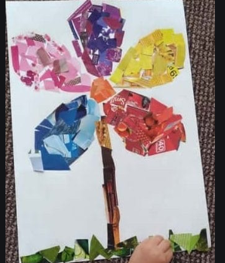
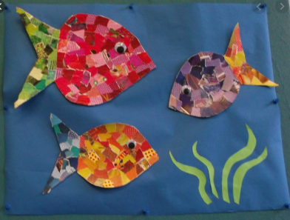
- If you have some crepe paper you could make some stained glass for your window and share it with us on our Breakaway Channel.

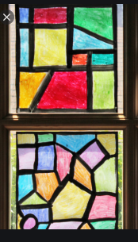
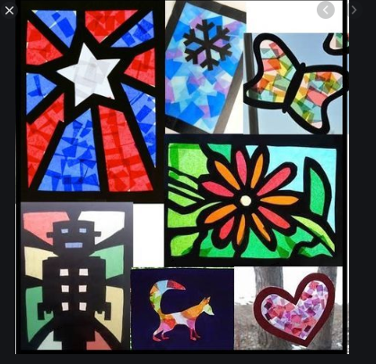
- In the files section there is an Art competition that you can complete.

Modern Languages
- Log onto Linguascope and revise some of the words you have already learned. The username is hmps and the password is hmps1.
- Have a look at the Great French and Spanish Challenges in the Modern Languages folder.
- Find out the French or Spanish words for foods, such as cheese, milk, eggs, chocolate, fish, chicken, bread and an apple.
Health and Wellbeing
- In class we would be starting to learn about substance misuse. Miss Barclay has uploaded information about this and an assignment.
- In the Health and Wellbeing folder I have uploaded some activities that you can work through.
- Go create your own Gratitude Jar. Mrs. Fairley uploaded information about how to make your very own gratitude jar.
Mapping Skills
I have uploaded a mapping worksheet for you to work on in the IDL section. You have worked on a lot of mapping work with Mrs. Carder during Outdoor Learning and we have worked on some mapping in the classroom. Remember to think about turning left and right, going straight and your compass points when you are describing directions.
Compass points – North, East, South and West.

Homework Challenge
Well done to those of you have already created your models! If you haven’t created yours yet, then remember this was to create a model of a setting from your chosen book.

