How to Use Immersive Reader in Teams

1.

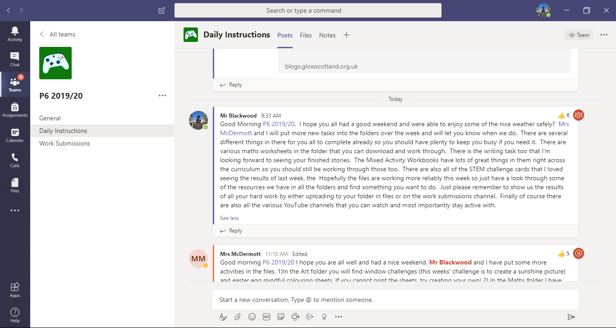

All of the instructions and important updates for P6 can be found in the Daily Instructions channel.

2.

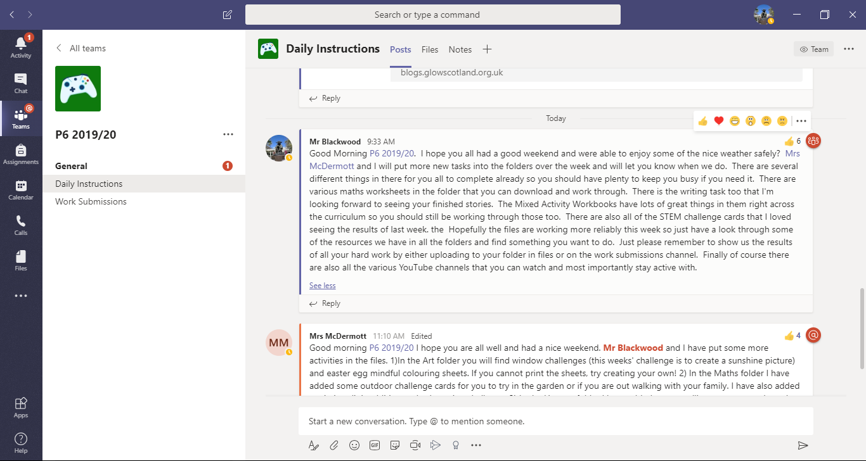

If you go to the post that you want to read and hover over it, then the little emoji list should come up in the top corner. Click on the ellipsis,’ ···’ at the end.

3.

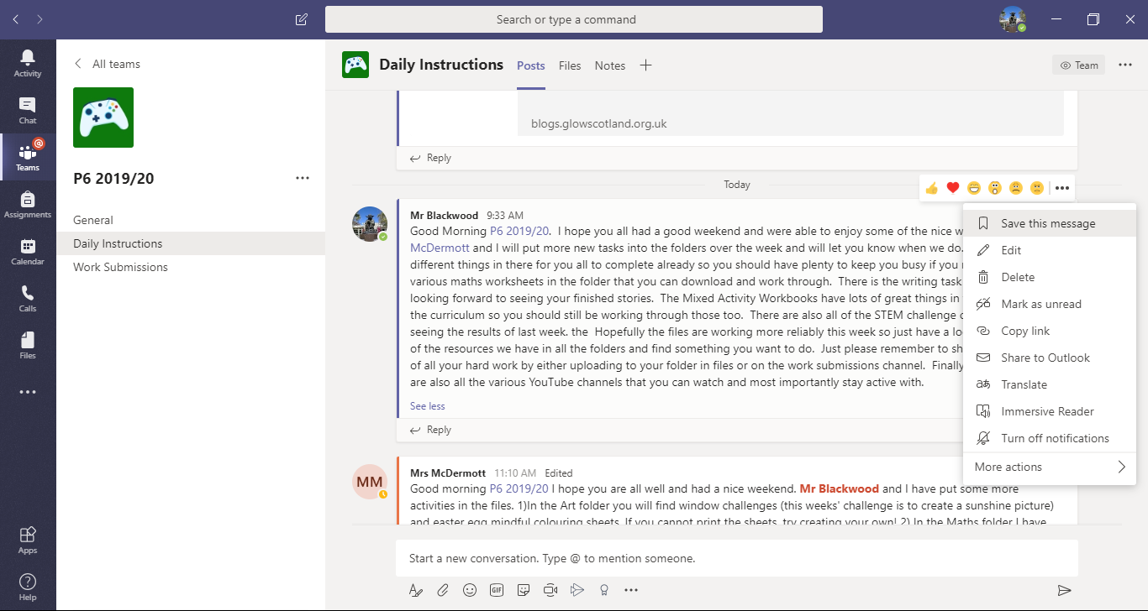

A little drop down menu should appear and you then want to click on the ‘Immersive Reader’ option that is 8th on the list.

4.

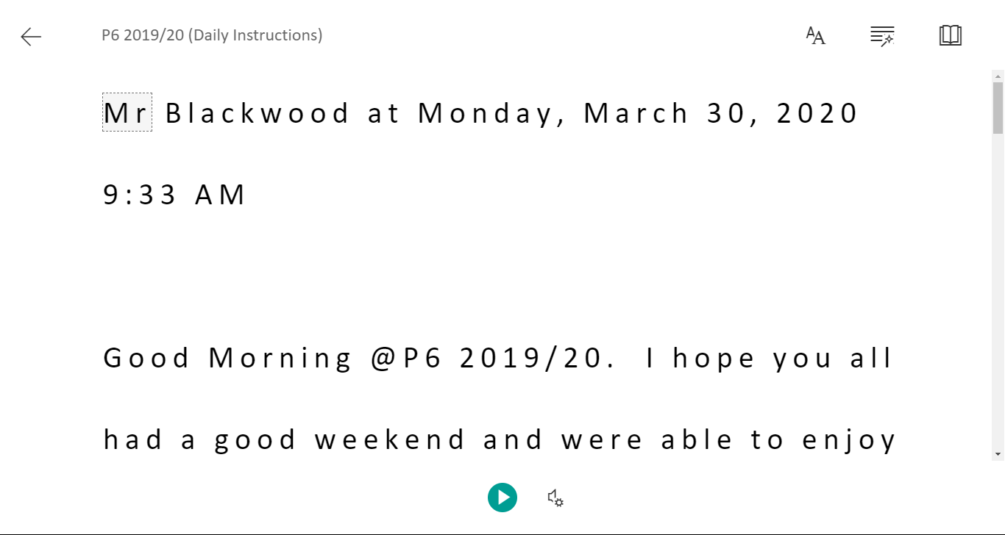

When you click on the play button then a voice will read out and follow along the text for you. You can get it to read it out loud as many times as you need.

There are then various options to adjust the text size or change the line spacing if you want to.

5.



When you are done listening to this post, then just click on the arrow to go back. You can then follow this process to listen to any other posts that you want.