Primary 1
Tricky Words
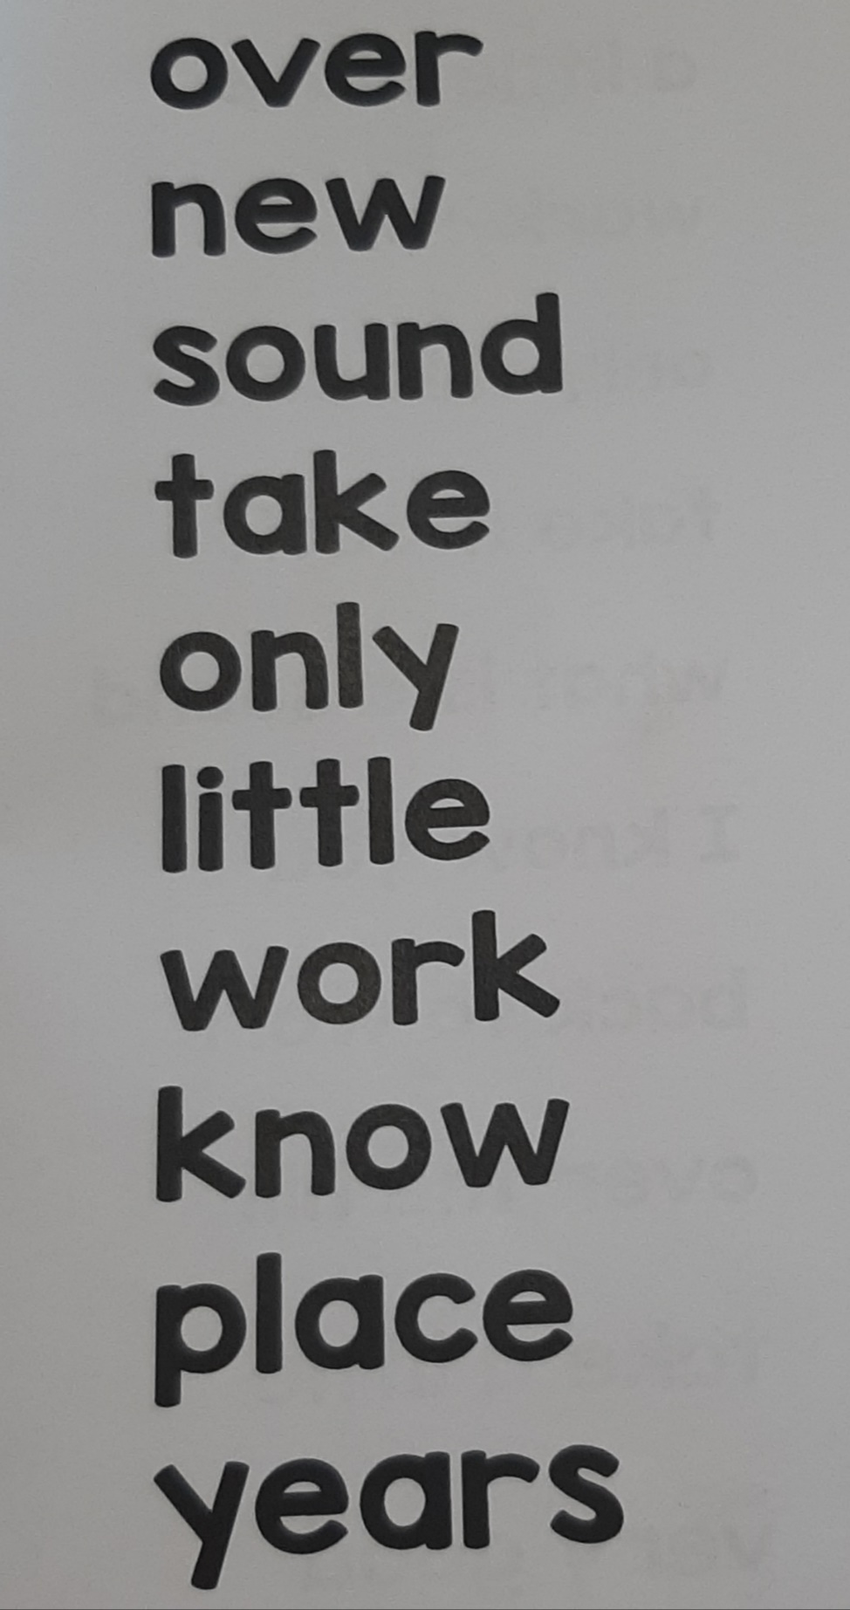
(Wk Beg. 15.06.2020)

