r
Phonics  Watch ‘Geraldine the Giraffe’ https://www.youtube.com/watch?v=R_NgOtt0Htw  What can you find in your house beginning with ‘r’?  Watch ‘Alphablocks’.  https://www.bbc.co.uk/cbeebies/watch/alphablocks-red  What ‘r’ words did you hear? Can you use some of them in a silly sentence?  Learn the ‘Jolly Phonics’ song for ‘r’  https://www.youtube.com/watch?v=xayfJnl6Bkk | Reading  Colourful Consonants & Vowel House  Reading Cards  Set 2 Card 3  Practise reading the sounds, words and sentence on the card.  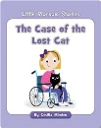  Read ‘The Case of the Lost Cat’ book on  https://www.getepic.com/sign-in/educator  (class code is yqs3050)  Remember to use your reading targets. | Tricky Words  Sight Words & Fluency Phrases  Booklet 1  Page 3  Look, say, cover, write, check each word using a variety of active spelling strategies  (e.g. rainbow writing, writing in salt, use stones etc).  Remember to practise reading them in different orders every time!
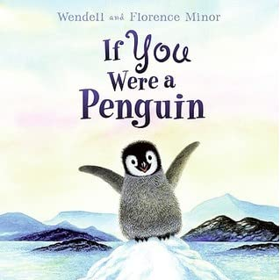  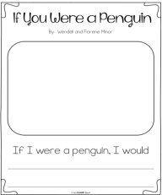  Writing  Listen to the story ‘If You Were a Penguin’.  https://www.youtube.com/watch?v=CWJyhbLodeE  What would you do if you were a penguin?  Draw a detailed picture and complete the sentence  ‘If I were a penguin I would…’ with your own idea.  Remember to use your writing targets. | P1 Learning Grid  Use the yellow jotter provided to record any learning experiences.  Upload photos of your child engaging with their learning to our school Twitter page. Remember no names please!  Eastertoun Primary School  *Remember to use the Education City, Studyladder, Sumdog and Charanga login details you have been given to access more online learning* | Interdisciplinary  Read ‘From Egg to Penguin’ book on https://www.getepic.com/sign-in/educator  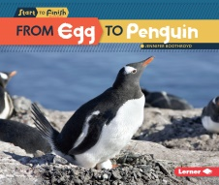  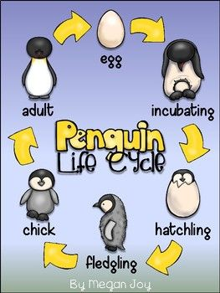  Draw and label a life-cycle diagram of a penguin which shows the journey of an egg to an adult penguin.
Numeracy  I can count in 5s.  https://www.youtube.com/watch?v=EemjeA2Djjw  http://www.sheppardsoftware.com/mathgames/earlymath/BalloonPopSkip.htm (select skip count 5)  Count the numbers of fingers in your house by counting in 5s. | Health and Wellbeing  Do the ‘Sticky Kids’ workout  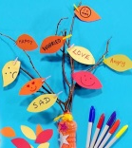  https://www.podbean.com/media/share/pb-f4n9k-d7c1f4?utm_campaign=w_share_ep&utm_medium=dlink&utm_source=w_share  Create a ‘Feelings Tree’ and talk to an adult at home about how you are feeling each day.  https://www.bbc.co.uk/cbeebies/makes/feeling-better-feelings-tree | Maths  I can position the numbers on a clock face.  https://www.youtube.com/watch?v=3y-7DgYK-Nc  http://www.learningplanet.com/act/tw/index.asp  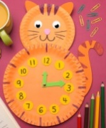  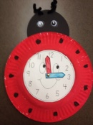  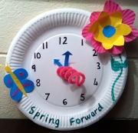  Make a paper plate clock face. Start by putting 12, 6, 3 and 9 on first then fill in the rest of the numbers.

