Primary 1 Art and Technology Choice Boxes
Upload any of your finished pictures to the school blog.
Drawing birds  Follow the drawing tutorial and learn to draw a bird.  https://www.youtube.com/watch?v=rzxRWTv237M | Creativity challenge  What can you make from one cereal box. Please make sure that it is empty! | Draw someone in your life as a superhero. Design a costume for them. What is their superpower?
Look for objects around your house to create your own colour wheel.  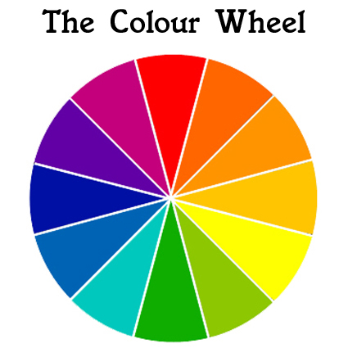 | Lego/building block challenge  NASA have hired you to build a spaceship. Build it out of Lego or any other building blocks you have. | Learning about birds  Look out of your window or go into your garden or while you are out for a walk see how many of the following birds you can spot. Look on the next page for them.  Using the YouTube video mentioned in box 1, can you draw one of the birds you have seen and colour it correctly.
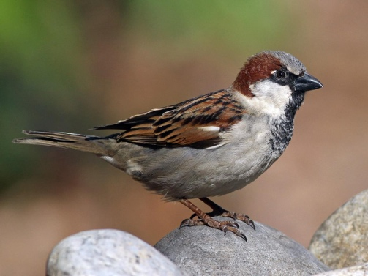  House sparrow | 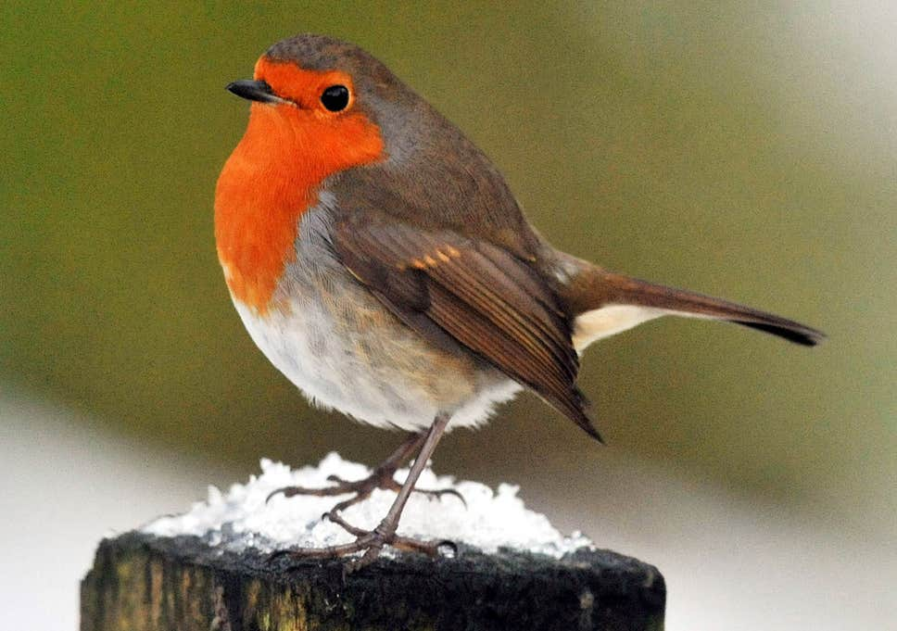  Robin | 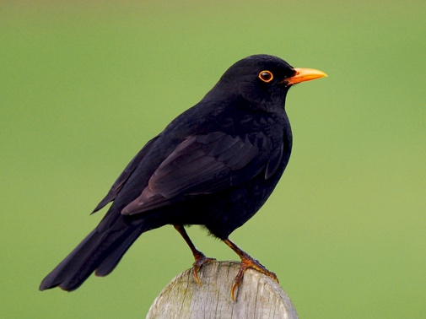  Blackbird

