Primary 1 Art and Technology Choice Boxes
Upload any of your finished pictures to the school blog.
Have a rainbow scavenger hunt  Find something red.  Find something yellow.  Find something orange.  Find something green.  Find something blue.  Find something purple.  Draw a fruit that is red.  Draw an animal that is yellow.  Draw a vegetable that is orange.  Draw a plant that is green.  Draw something outside that is blue.  Draw a flower that is purple. | Creativity challenge  What can you make from one cereal box. Please make sure that it is empty! | Draw someone in your life as a superhero. Design a costume for them. What is their superpower?
Follow this drawing tutorial and learn how to draw a butterfly. Once you have drawn it, colour it in. Remember that butterflies are symmetrical (the same on both sides).  https://www.youtube.com/watch?v=cx6jbl1lOG8 | Lego/building block challenge  NASA have hired you to build a spaceship. Build it out of Lego or any other building blocks you have. | Learning about birds  Look out of your window or go into your garden or while you are out for a walk see how many of the following birds you can spot. Look on the next page for them.
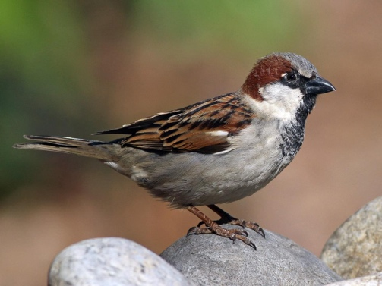  House sparrow | 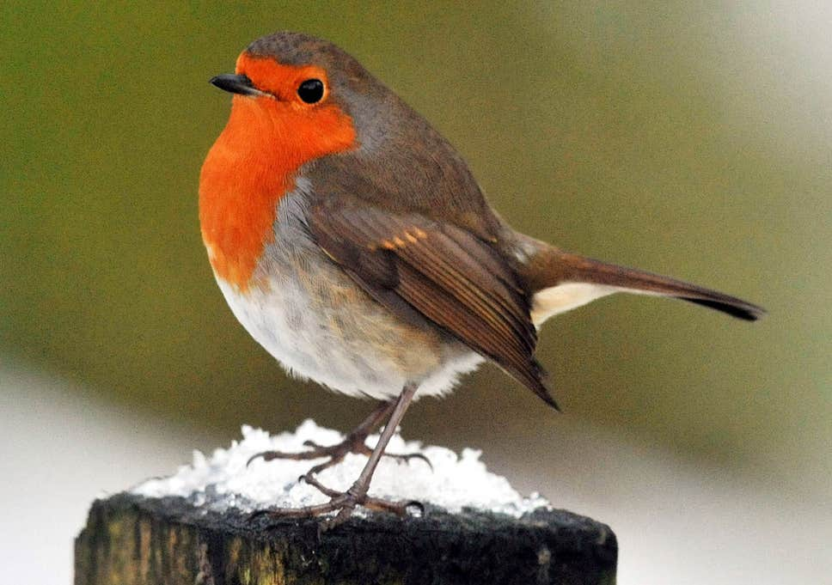  Robin | 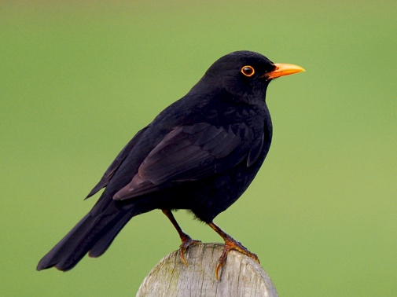  Blackbird

