Prediction
Prediction is the skill of taking a good guess at what is going to happen next. We use clues and evidence to make sure it is a good guess and not a silly one. Try your prediction skills out on the story below and follow the instructions carefully so you stop the video at the right time to have a guess. Good luck!
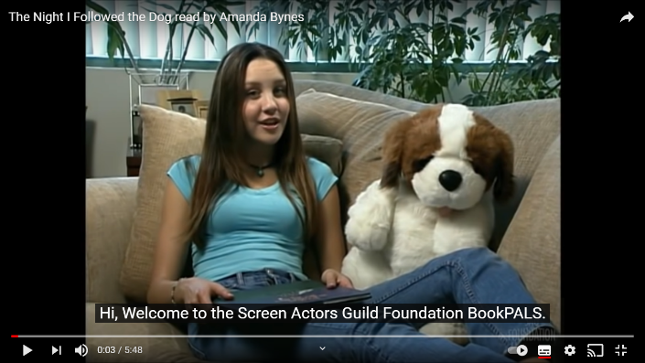

https://www.youtube.com/watch?v=Je39PxnjveY
Prediction Skills for The Night I Followed the Dog

- Stop video at 21 seconds. What do you think this book is all about? Remember the evidence to support your idea.

- Stop video at 1.20 seconds. The boy in the story saw something odd regarding his dog. When he whistled for his dog and it came into the kitchen what do you think his dog will look like?

- Stop the video at 1.54 seconds. What do you predict the doghouse (kennel) is going to look like?

- Stop the video at 2.47 seconds. Where do you think the dog was going?

- Was this an easy story to predict? Give a reason for your answer.

