Name: Date:

Spelling Pictures:
Choose at least 5 of your words to draw a picture of. You can do more than 5 if you wish, Please remember to write your spelling words underneath.
For example:
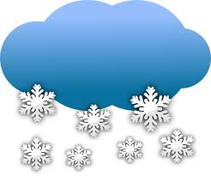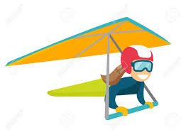
Snow glide

