Pupil’s Core Writing Targets  Second level  Name:…………………………………………. | 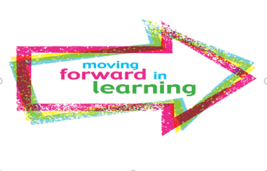
I can
- create texts regularly for a range of purposes and audiences selecting appropriate genre, form, structure and style
- spell all commonly used words correctly by applying spelling rules and strategies
- spell less commonly used words with accuracy
- confidently and accurately use capital letters, full stops, commas, inverted commas, exclamation marks, question marks and/or apostrophes
- use sentences of different lengths and complexity
- ensure sentences are grammatically accurate, nouns, verbs and tenses agree
- accurately use paragraphs to separate ideas/events
- use a wide variety of conjunctions/connectives to link ideas and join sentences, eg.furthermore, nonetheless
- proof read and edit writing accurately
- use linked, legible handwriting to present work attractively using correct forms of layout

