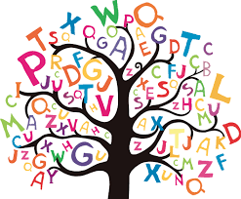 Spelling Activities
Spelling Pyramids  Complete a spelling pyramid for each of your spelling words | Rainbow Writing  Write each of your spelling words out using a different colour for each letter | Sentences  Write a sentence for each of your spelling words
Paragraph  Write a paragraph containing as many of your spelling words as you can – read over it to make sure it makes sense | Graffiti Wall  Create a graffiti wall using each of your spelling words | Spelling Tennis  Throw a ball with a partner, taking turns to say the next letter in your spelling word
Backward Spelling  Look, say, cover, write and check – backwards! | Spot the Error  The person helping you with your spelling writes the word incorrectly – spot the error and write the word correctly | Back Writing  Work with a partner to write your spelling words on each other’s backs, try to guess what the word is
Word-search  Create a word-search containing your spelling words on squared paper – remember to write them at the bottom! | Cut and Stick  Cut letters out of old magazines/newspapers and stick them down to create your spelling words | Consonants and Vowels  Write your words out using one colour for consonants and another colour for vowels
Alphabetical Order  Write your words out in alphabetical order | Flashcards  Make a set of flashcards for practising your words at home | Clap out the Syllables  Break the word down into syllables and clap them out then write your word, breaking it into syllables
Rhyming Words  Find a word that rhymes with each of your spelling words | Spelling Noughts and Crosses  Challenge someone to spell a word, if they spell it correctly they can fill a box, remember to take turns | Spelling Flowers  Write the whole word in the middle of the flower and each individual letter on a petal

