Jigsaw – Dreams and Goals – Lesson 2
I can work out the steps I need to take to achieve my dreams and goals
I can recognise how to bring about change in myself and others

“Life isn’t about finding yourself. Life is about creating yourself” George Bernard Shaw
What do you think this means?
Explain:

In our world there has always been change and developments. The industrial revolution is an example of this:
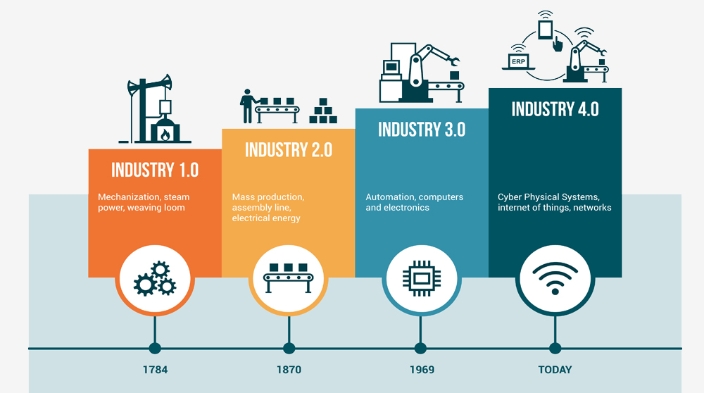

However, nowadays the pace of change is much faster.

Here are the top 10 skills you need to thrive according to the World Economic Forum – these are the skills that are CURRENTLY being seen as the most important, however, the pace of change is so rapid that these are likely to change.
1. Complex problem solving
2. Critical thinking
3. Creativity
4. People management
5. Co-ordinating with others
6. Emotional intelligence
7. Judgement and decision-making
8. Service orientation
9. Negotiation
10. Cognitive flexibility

Choose one of these above skills that you have not yet mastered.
What steps could you take to develop this skill?
How will you ‘create’ yourself to meet the challenges of our world today?

Copy and complete the following table. I have completed an example for you.
What would you like to learn? | How will you learn/acquire the skill? | How will you know you have mastered the skill? | How do you think this will make you feel? | How can you encourage others to keep trying when learning something new?
Musical instrument | Take lessons from someone who knows how to play the instrument | I will be able to play a tune | A sense of achievement

“I already know what giving up feels like.
I want to know what happens if I don’t”
Neila Rey

