Calculating Time Intervals

This is a TV schedule:

Programme | Start Time
X-men 3 | 10:30am
Superman | 12:45pm
Spiderman | 2.15pm
Flora and Friends | 3.40pm
Blue Peter | 4.05pm
Newsround | 4.30pm
How to be Epic at Everything | 4.40pm
The Daredevil | 5.00pm
Sidekick | 5.25pm

1. What time does Spiderman start?
2. What time does Blue Peter end?
3. How long does Flora and Friends last?
4. How long does The Daredevil last?
5. Simran watches Newsround and How to Be Epic at Everything. How long does she watch for?
6. How long does Sidekick last?
7. Sidekick lasts for 15 minutes. What time does it finish?
8. If Edmund watched X-Men 3 and Superman, how long did he watch telly for?

Challenge: How long from the start of X-Men to the end of The Daredevil?

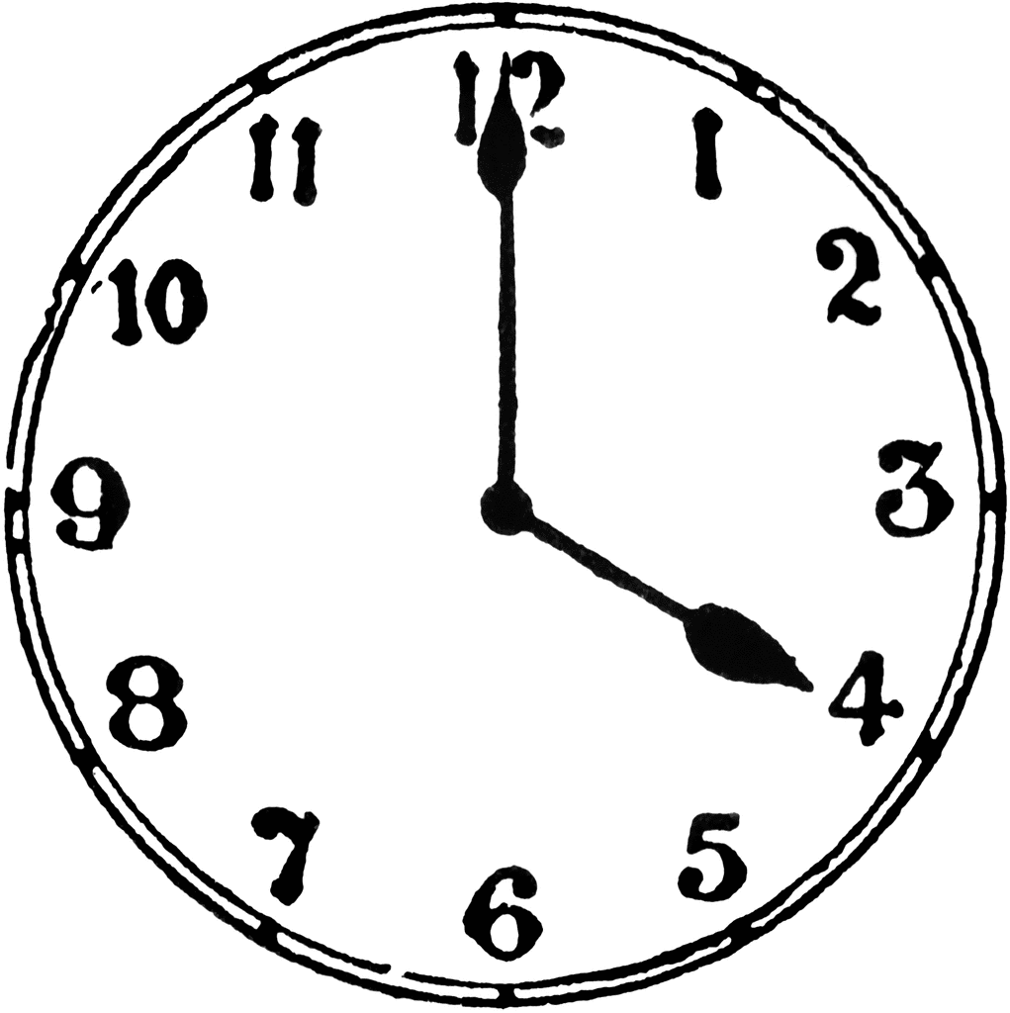
REMEMBER: YOU CAN USE ONLINE CLOCKS TO HELP YOU COUNT ON THE TIMES.

