**I can calculate time intervals using the 24 hour clock**

Your task today is to help the three little pigs! Using the times below calculate how much time they have in between the wolf leaving and the wolf returning. Write down your calculations **and** answers (in hours and minutes).



1. Calculate the time intervals between:
2. 12:00 – 14:25 8) 12:12 – 16:42
3. 16:50 – 19:15 9) 17:59 – 18:11
4. 17:45 – 21:30 10) 01:17 – 19:10
5. 11:20 – 15:40 11) 09:41 – 16:02
6. 12:15 – 20:10 12) 10:26 – 14:09
7. 09:40 – 18:25 13) 11:57 – 16:21
8. 13:05 – 19:00 14) 12:19 – 15:18



B) Using the start time and length of time the wolf was away for find what time he returned. Record your answers in your book using the 24 hour clock.

1. Start: 15:25. Away for: 1 hour 10 minutes.
2. Start: 10:10. Away for 2 hours 55 minutes.
3. Start: 12:24. Away for 6 hours 5 minutes.
4. Start: 16:40. Away for 4 hours 25 minutes.
5. Start: 17:19. Away for 5 hours 32 minutes.

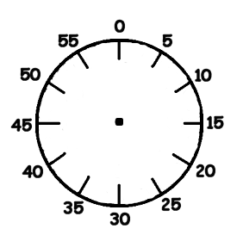

**EXTENSION:**

1. Convert your answers in A to minutes. E.g. 5hr 10min 🡪 310 minutes.
2. Convert your answers in B to the 12 hour clock. E.g. 16:10 🡪 4:10pm